**Tinyml**

[**https://github.com/LinkedInLearning/learning-tinyML-2447146/tree/main**](https://github.com/LinkedInLearning/learning-tinyML-2447146/tree/main)

Edge impulse –software

TIny ml we collect data right where it is generated

Running models in edge devices edge computing

But we have to do processing training and evaluating

Tiny ml help to optimise the models efficiently so we can deploy our phones

1. Identify how to use TinyML for ur next project
2. Implement software optimisation techniques
3. Choosing right hardware
4. TinyML ecosystem
5. Deploy first TinyML project

Ever wondered, how does your phone know when you're talking to it? Come step into the world of TinyML where you can learn about processing huge AI models right in the palm of your hand. Hi, I'm Archana and I'll be your guide in this journey of learning TinyML. Check out this course to see machine learning in action through your phone and IoT devices, all around you. This course will take you through identifying possible TinyML projects. Then move on to optimization techniques like pruning where you will learn about removing neurons from a network. Finally, we will get a chance to execute voice recognition on your own phone, through edge impulse. So what are you waiting for? Drop your phone. Join me in the course and build your first TinyML project.

Did you happen to say hey, Siri, hey, Google or hey, Alexa today? We have IoT devices all around us. It is estimated that the world has close to 35.82 billion IoT devices right from our smart home devices to our mobile phones to even devices deployed to remote forest or deserts. Further, as you go about your day, you might take a car or smart buses or even trains, and interact with many smart devices. Each of them has an IoT device and use data to make smart decisions. When you say hey, Siri or Google or Alexa, your voice assistant immediately answers, "How can I help you today?" Ever wondered how can it do that? It uses keyword detection, which runs right on your phone or the voice assistant device. This means all the processing happens right there on the device without interacting with the server and that is TinyML, using optimized machine learning algorithms on smaller devices, like mobile phone and embedded system. Welcome to the course for Learning TinyML. We are so excited to have you join us in this journey. Current machine learning systems have data collection, data processing, training, and then testing of models. With TinyML, you can collect your data right where it is being generated like when you say hey, Google, your phone listens for that information to recognize you. You can also provide it with voice samples when setting up the device so it can store information. This is called edge computing since you are running models at the edge where the data is being generated. You would still have to do data processing and training on your CPU or GPU. But you can now take this trained model and deploy it to any small device like a microcontroller or even your mobile phone. So why do we need to perform TinyML to run on our phones? Traditionally, deep neural networks are composed of floating-point values. They also require massive amount of computational power and memory to execute. But as we move towards embedded devices, like mobile phones, the memory is constrained and you cannot deploy large, power-hungry models. So TinyML helps to optimize your model efficiently so that you can deploy to these small devices. What will you learn from this course? In this course, you will have the opportunity to identify how to use TinyML for your next project, implement software optimization techniques, choose the right hardware for your next project, learn about the TinyMLOps ecosystem, and apart from this, you will also have a chance to deploy your first TinyML project and try your hand at several optimization techniques. Finally, this course will open you up to great opportunities in the industry. The number of IoT startups is increasing at an exponential pace. Market Watch has estimated that "the global edge computing market is forecasted to reach $8.96 billion by 2023, expanding at 32.6%." And Fortune Business Insights thinks that more than 50% of that will be dealing with device management and building a cloud platform. Furthermore, TinyML and edge computing are also being adopted by large organizations like Google, Amazon, Intel, Dyson, Microsoft, and so on. At the time of building this course, there were more than 8,000 approximate open full-time positions for edge computing, with half of them being entry-level to mid-senior level position. This number is only going to increase as more companies and startups adopt TinyML. So let us get started with our TinyML course.

TinyML protect data by processing it in the location it is generated.

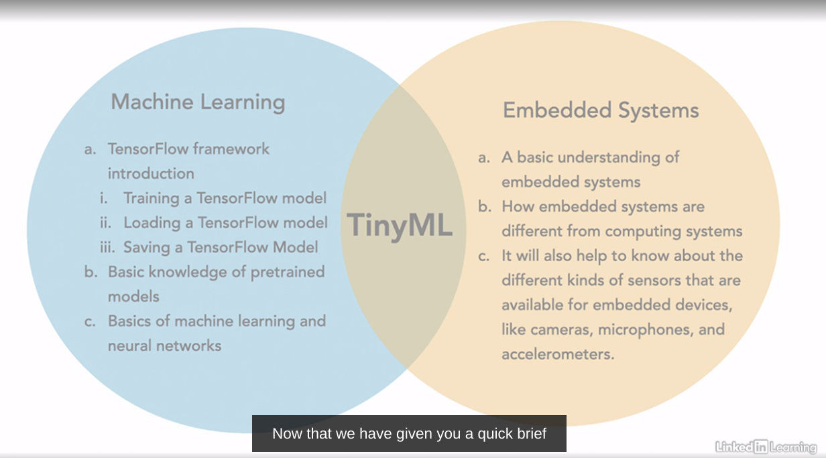

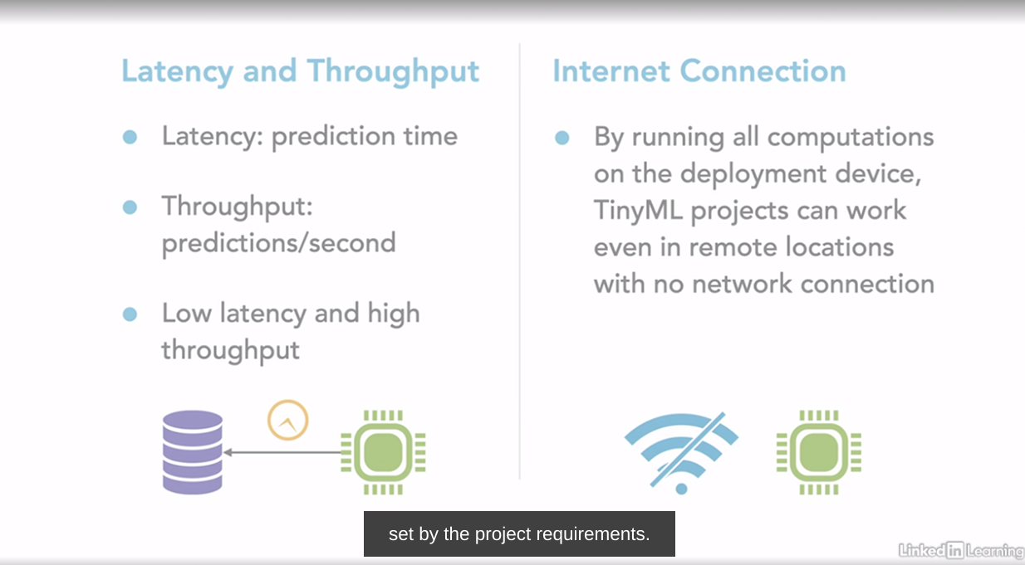

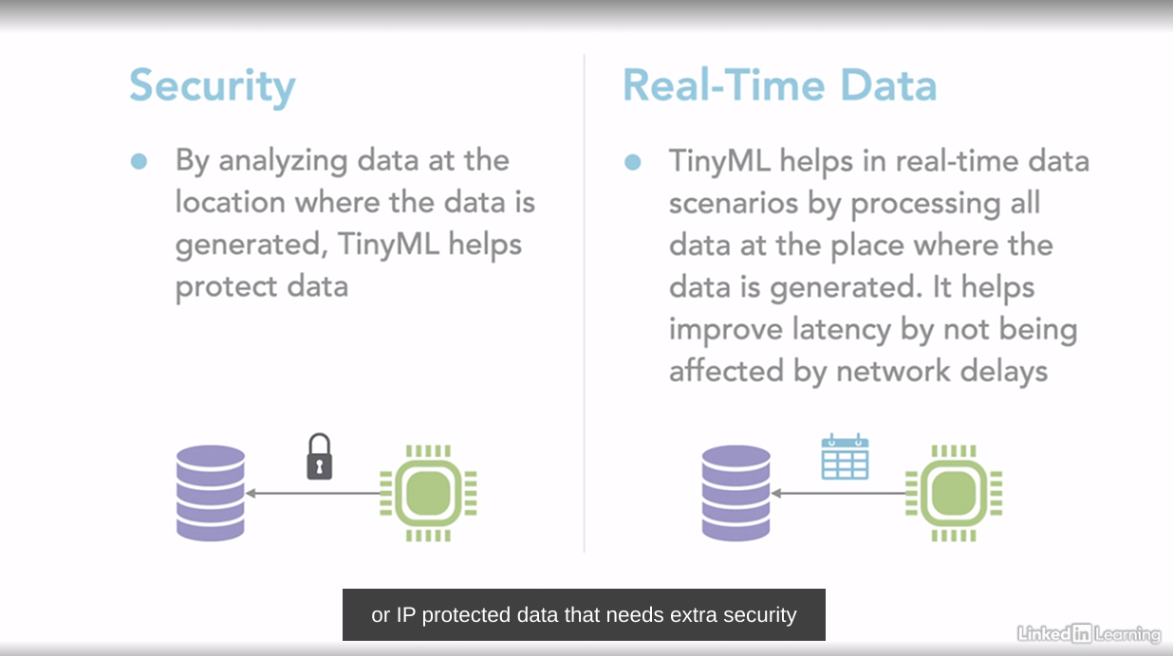

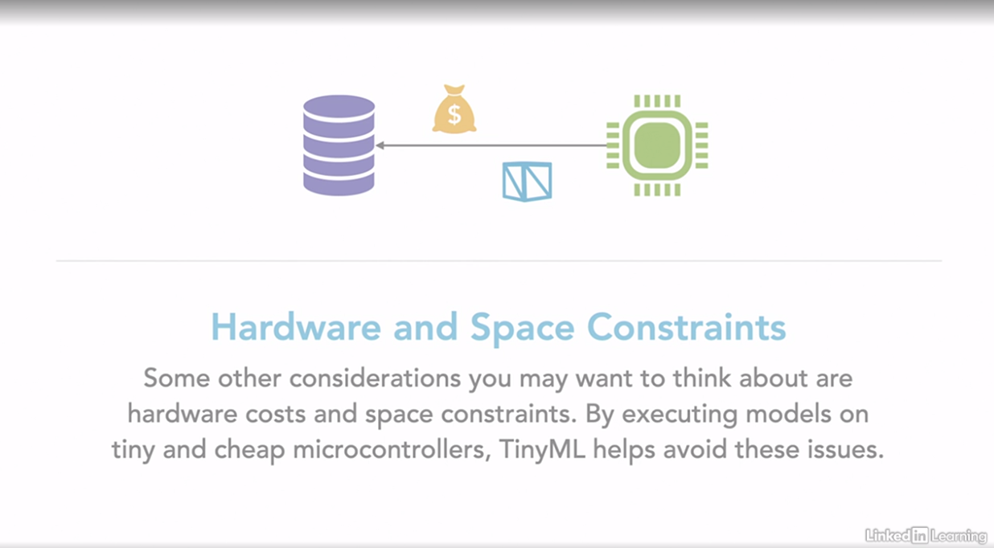

**Checklist**

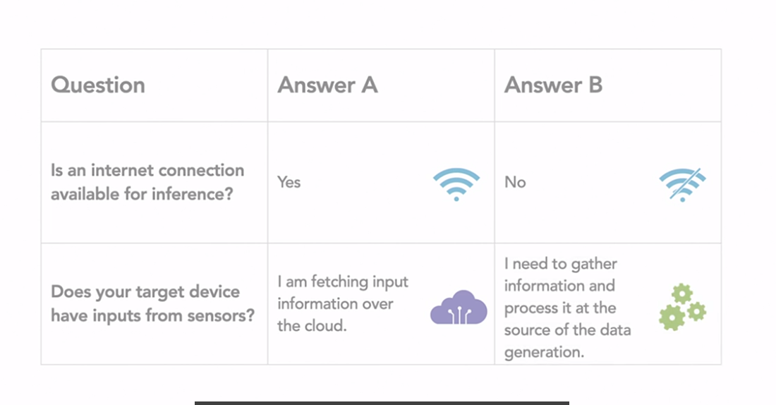

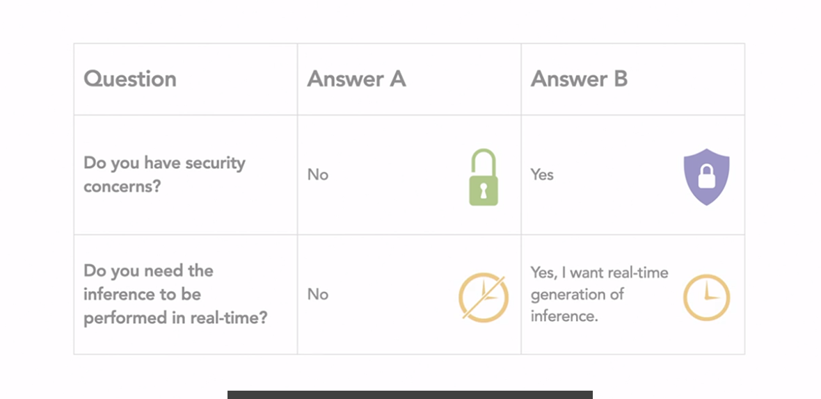

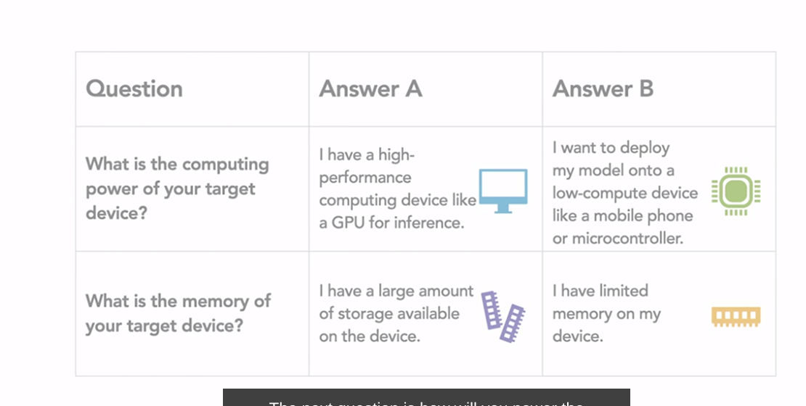

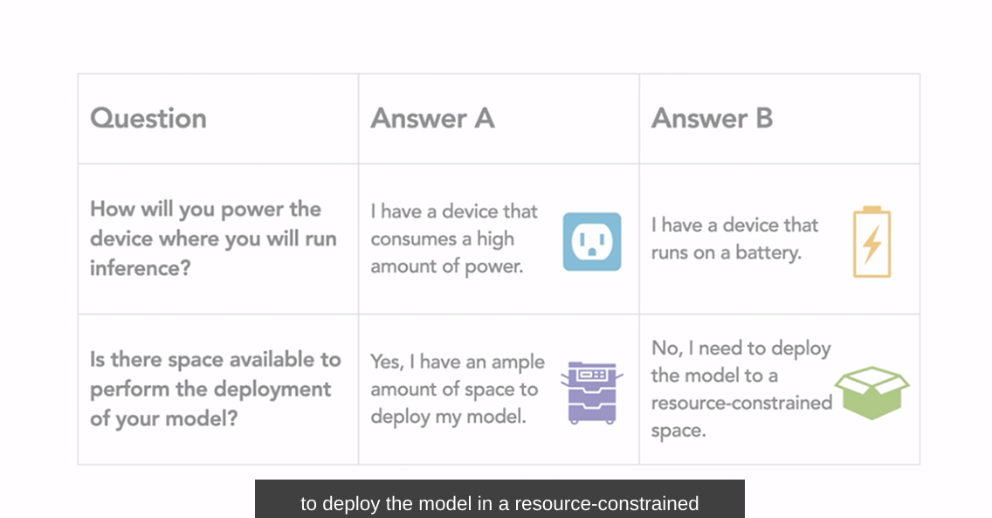

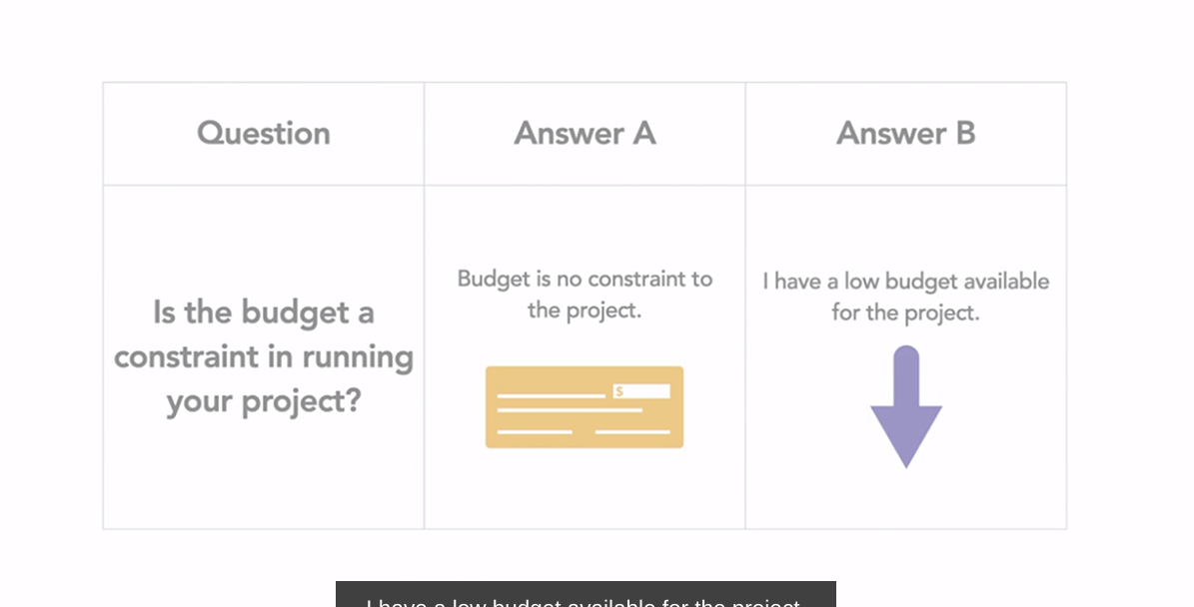

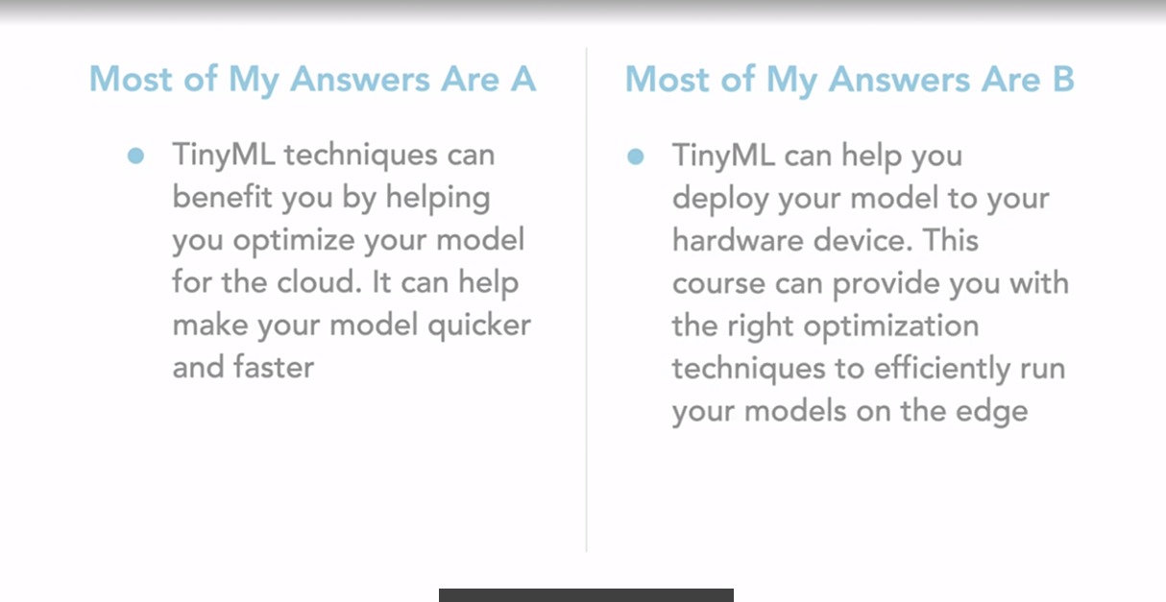

**Pre-trained model for TIny ML**

**Pretrained models for Tiny ML. Vision recognition is a task that requires that models have high accuracy. To do that, we have traditionally built deep neural networks with increased layers and computational power. Memory is one of the biggest bottlenecks in these networks. A ResNet-50 model requires over 23 million parameters to execute. To run these heavy networks, we need a GPU or a graphical processing unit which can perform parallel computations to speed up inference. But how do we run them on edge devices which have low memory, low compute, and low power and cannot perform parallel computations? We need to optimize them to reduce the size and the number of operations. Additionally, we could also use models that have already been optimized and fine tune them for our task. These are called pretrained models. In this lesson we will be learning about the commonly used pretrained models and the different optimization techniques you can use to run your model on the edge. Now that we have learned about the different issues with large models, let us define the goal of our edge computing model. Firstly, the model should load faster at the edge. Since memory is less at the edge, the model should be small. The model should also require less operation to execute it due to low compute power of edge devices. The model should execute quickly. And finally the accuracy of the model should be high. It is important to note that our goal is to increase inference speed rather than accuracy. You can expect some losses as you optimize or compress your model, but with the right optimization techniques, it is possible to keep these losses to a minimum. Let us first take a look at two of the most commonly-used pretrained model. MobileNet. The MobileNet model splits a standard convolution layer into two simpler layers to build lighter networks. They are called separated set convolutions. The first layer is the depth-wise convolution which is then followed by a point-wise convolution. These convolution layers help to reduce the weights needed to be stored and also the number of operations required to execute them by keeping the input and the output shapes to the layer the same as those of the standard convolution. By doing this, the total number of operations of floating point operations reduces in a network, helping it to run on low power devices. The MobileNet V2 model, when tested on ImageNet data set gives 70.6% accuracy with just 4.2 million parameters. In comparison, a GoogLeNet model with a similar accuracy of 69.8% needs 7 million parameters. While the original MobileNet model has been trained on the ImageNet dataset, you can use transfer learning to fine tune it on a dataset of your choice. Efficient Net. Efficient Nets are a popular group of pretrained models used in edge computing. Efficient Nets were built, keeping scaling in mind. Conventional scaling methods increase the width or depth of various networks like channels, filters, et cetera. Efficient Net, on the other hand, use compound scaling in a structured manner. This allows them to be computationally efficient while still having high accuracy. The smallest Efficient Net model, the BO, with 5.3 million parameters reaches 77.1 accuracy on ImageNet as compared to ResNet-50 with an accuracy of 76% and 25.6 million parameters.**

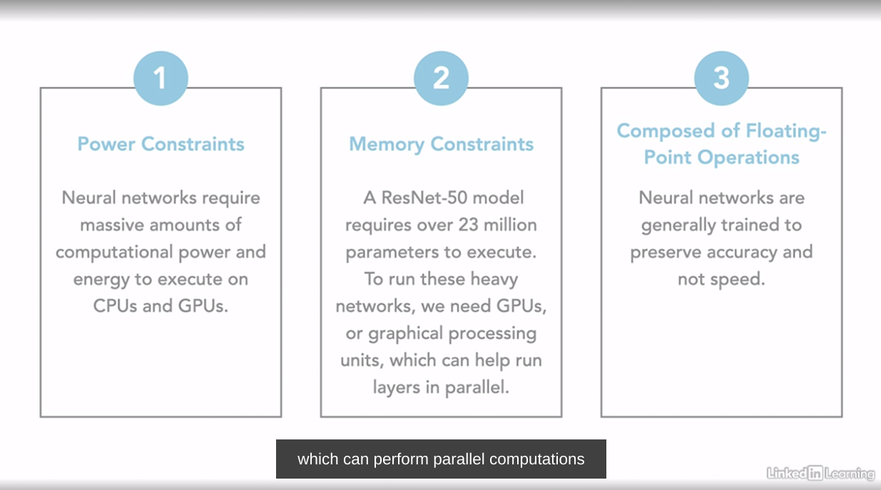

Optimise model to reduce size, computation and fine them for our task

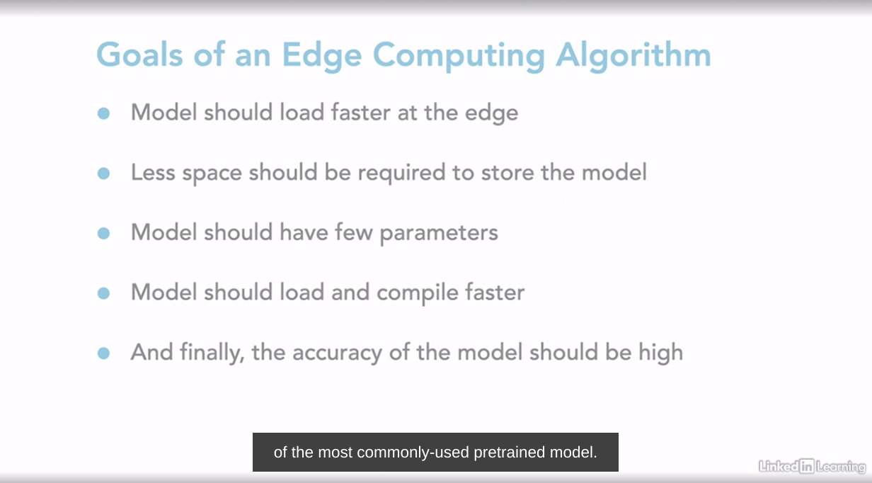

Restnet , Mobilenet

**Optimisation Technique for edge devices**

**Quantization**

Used in Signal Processing >> rounding the decimals >> large value are mapped to smaller values by this we manage to remove the noise from the other digita weaves. NN use FLoating point weights and bias they are very crucial since they give them precision during training help model to converge and provide best results possible but they require more memory to store and computation to execute also require more memory to store and computations to execute. These higher precision floating point values require 32-bit or 64 bits to store for FP32 and FP64 respectively.

When we look at neural networks, we know they often require large computational and memory power to execute. Therefore it becomes vital to optimize them for inference on tiny ML devices. In this lesson, we will be learning several optimization techniques. Starting with quantization, which is the most commonly used. Quantization is commonly used in signal processing. Rounding is one example of quantization. To round a number we map large values, which are input to a smaller set of values, which are output. In this manner we are able to remove noise from signals in other digital waves. Neural networks, as you know, use floating point weights and biases. Floating point values are crucial for neural networks since they give them precision during training. Floating point values help models to converge and provide the best results possible. However, the same floating point values also require more memory to store and computations to execute. These higher precision floating point values require 32-bit or 64 bits to store for FP32 and FP64 respectively. As the network becomes larger, more weights are added, further compounding the problem. So to reduce higher precision computations, we move towards lower precision values. Just like we do rounding and truncation for signal processing, we use the similar techniques for neural networks. These lower precision are integer values, INT8, which can be computed quickly and require only eight-bit to store. Thereby helping to run our predictions quickly and while using less space. When we run our models in a quicker manner, our overall latency reduces. How do we quantize a neural network? Now that we have learned why quantization is vital to neural networks, let us look into how we can apply it to our pipeline. Let us do a quick recap into how a typical neural network is executed. We fit in our input values to our network. To move from one layer to another, we multiply the activation with weights and then add bias values. Floating point values can be present in the input and are used in the weights and biases for each layer. To apply quantization, we would have to quantize those values. We scale the values between the range of minus 127 to 128, which represents INT8, thereby making it lower precision. This brings us to types of quantization. Weight quantization and weight and activation-based quantization. When we perform weight quantization, we convert all weight values to a lower precision. This reduces the size of the model. However, when we execute the model, we need to convert our weights back to their full precision. So while we do get a lot of memory savings, there are no latency savings. And there is a tiny overhead of up converting all weights to higher precision. When we perform weight and activation-based quantization, we need to quantize the activation to lower precision when executing the model. By restricting all computation to INT8 precision, we can decrease the computation latency as well as the model size. However, there is a trade-off with quantization. Since we convert large floating point values to lower-bit precision, we lose out on information, which leads to lower accuracy values. In the next chapter, we will look at ways to preserve this information and train networks to account for this accuracy drop.

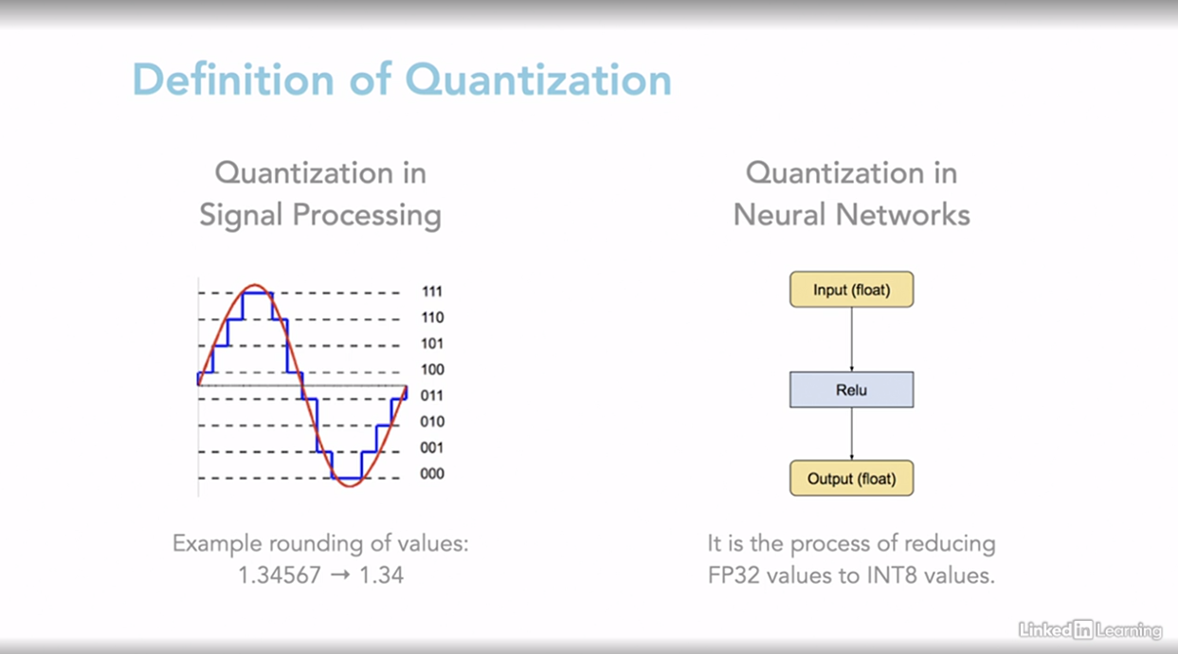

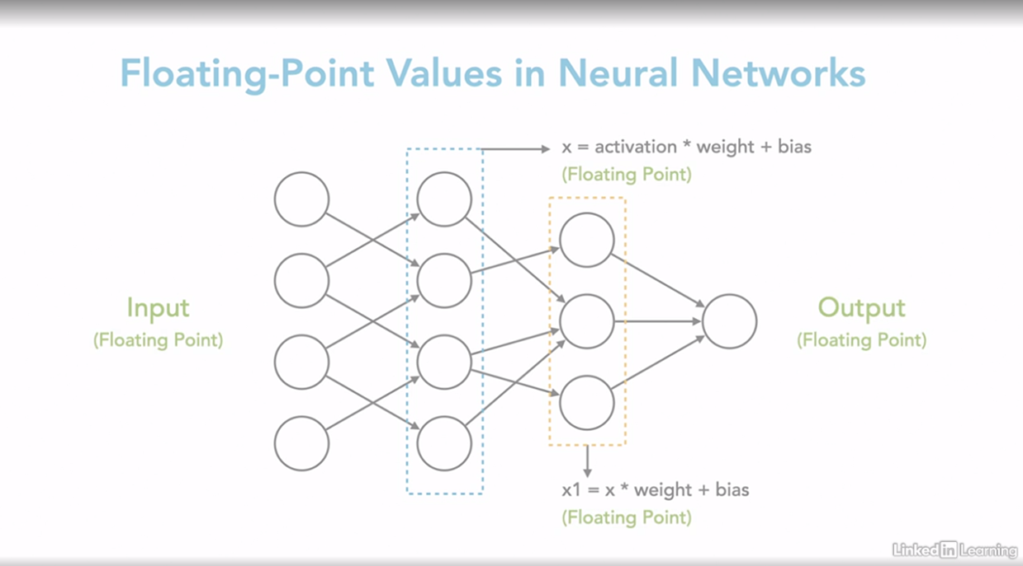

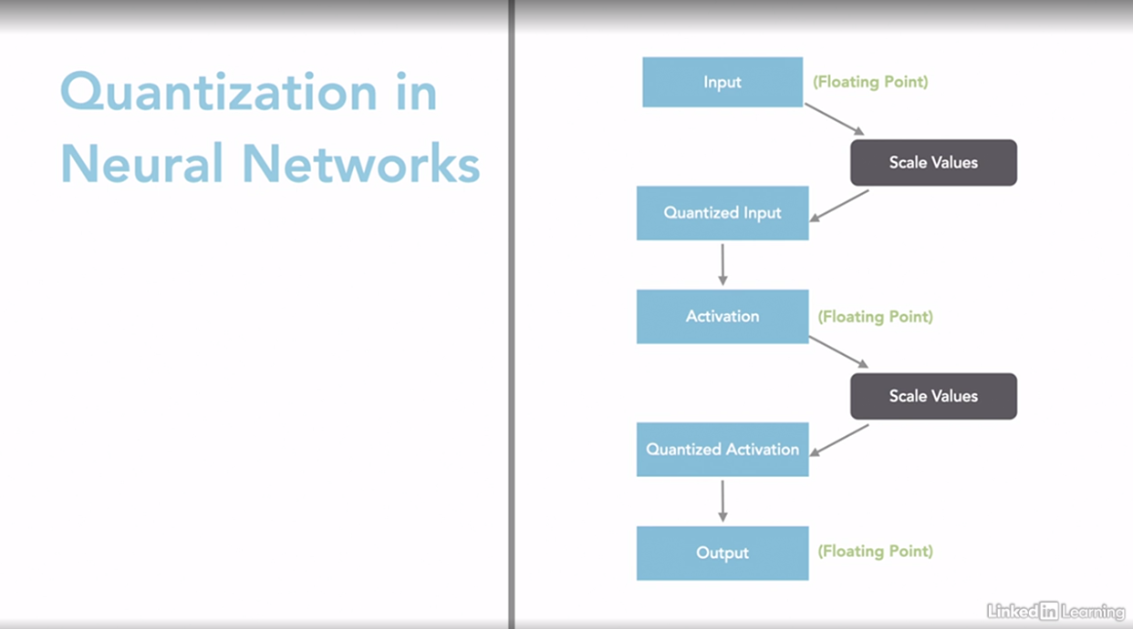

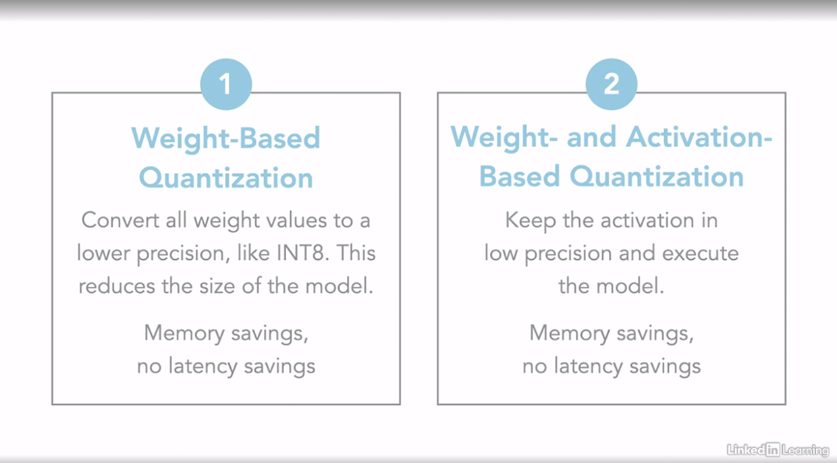

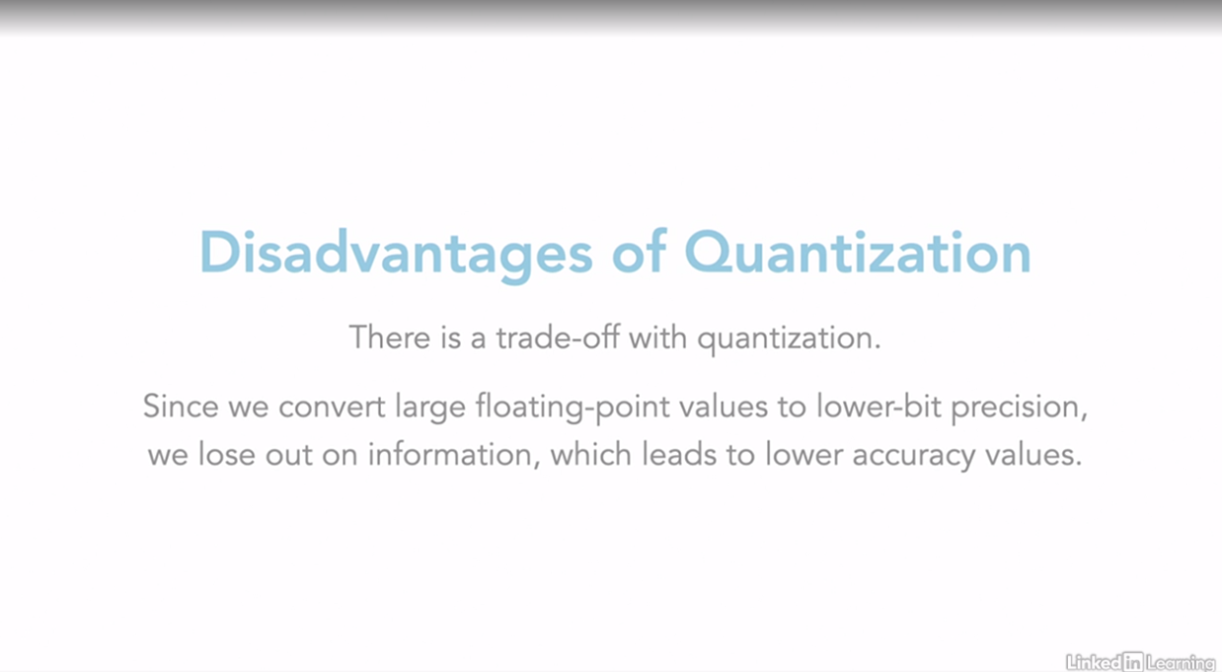

**TFLite post training quantazation**

Now that we have learnt about quantization, let us get into some code to quantize a neutral network. In this lesson, we will look into TensorFlow Lite, which is a popular framework for TinyML. TensorFlow Lite is an open source deep learning toolkit used for optimizing models and on device inference. TensorFlow Lite helps you pick a new model, convert it to an optimized format, using TensorFlow Lite Converter and then deploy this compressed file onto a microcontroller embedded device or your own mobile phone. As we have learned in the past that any embedded device or mobile phone has a low memory and compute power so optimizing the model before deployment is important. TF Lite also supports this through quantization and pruning. Currently, TF Lite supports post-streaming quantization and quantization-aware training. You will have a chance to try both of them in this chapter. So let us get started. Post-training quantization, as the word suggests, is a quantization technique applied after training of the model after training a TensorFlow model. It is composed of floating point values. So you take this model and convert it a TensorFlow Lite format. Our goal through quantization is to reduce the precision of the parameters of the model. There are several optimization methods available in post-training quantization. Float16 is the simplest quantization methods and reduces the precision to float16. Next is dynamic range quantization. This quantizes the weights in the model from floating-point to integer values. The last one if full integer quantization. This type of quantization helps to quantize the model that is the weights, biases, and the activations as well. Float16 is the simplest quantization and helps to reduce the precision to float16. When we train neural networks, it is trained on higher precision values of float32 or float64. So reducing it to floating point 16 can give us memory savings. There are several advantages to float16 since it's closer to actual floating point precision. It causes minimal loss in accuracy value, and can run on GPUs. The first step is to import the TensorFlow package. Then create a converter object using the saved_model file. Next, we specify the type of optimization we want to do in quantization level. In this case, we choose the default optimization and float16 spec. Finally, we call the convert function to quantize our model. Another quantization technique is dynamic range quantization. This type of weight-based quantization is what we learned in our previous lesson. This quantizes the model parameters from floating-point values to integer values. However, at inference, the weights are converted back from integer to floating-point value. This helps to reduce any drop in accuracy. So the dynamic range quantization provides memory savings but no latency savings. Dynamic range quantization is similar to how we did float16 quantization. However, in this case, we do not need to specify the quantization level since tf.lite will quantize to integer precision by default. Full integer quantization helps to quantize the model, that is weights, biases and activations as well. Since we are quantizing all the parts of the model, as well as using those quantized parameters for inference, it leads to the highest drop in accuracy. A full integer quantization can provide both memory and latency savings. Unlike the previous quantization codes, in this case, we need to provide a function with some sample training data. When quantizing the model, TF Lite uses this to calibrate activation ranges for the quantization process. We need to provide this representative dataset to our converter object. Next, we need to specify the quantization spec, which in this case is int8 and also tell the converter that both our input and output precision will be int8. Finally, we can quantize the model.

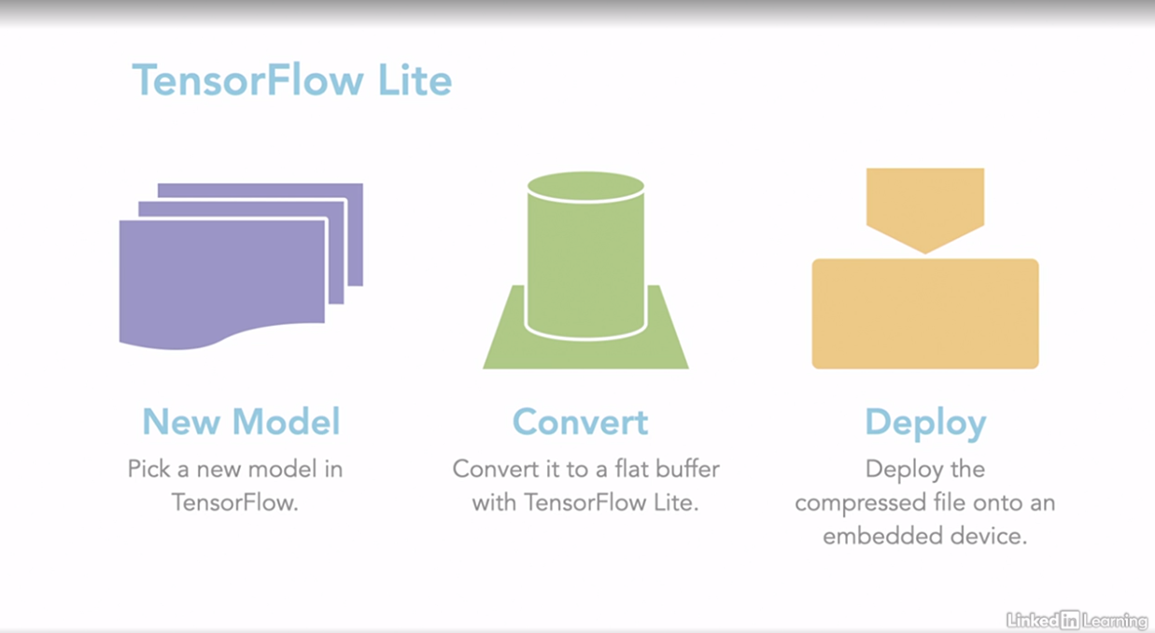

TFlite support post training quantazation and during training quantazization

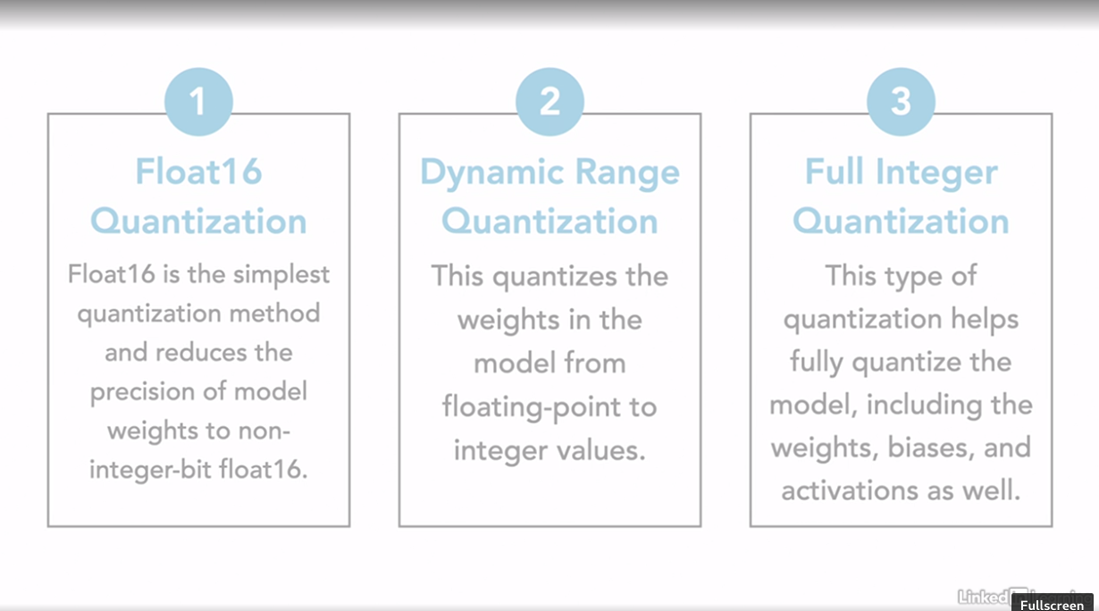

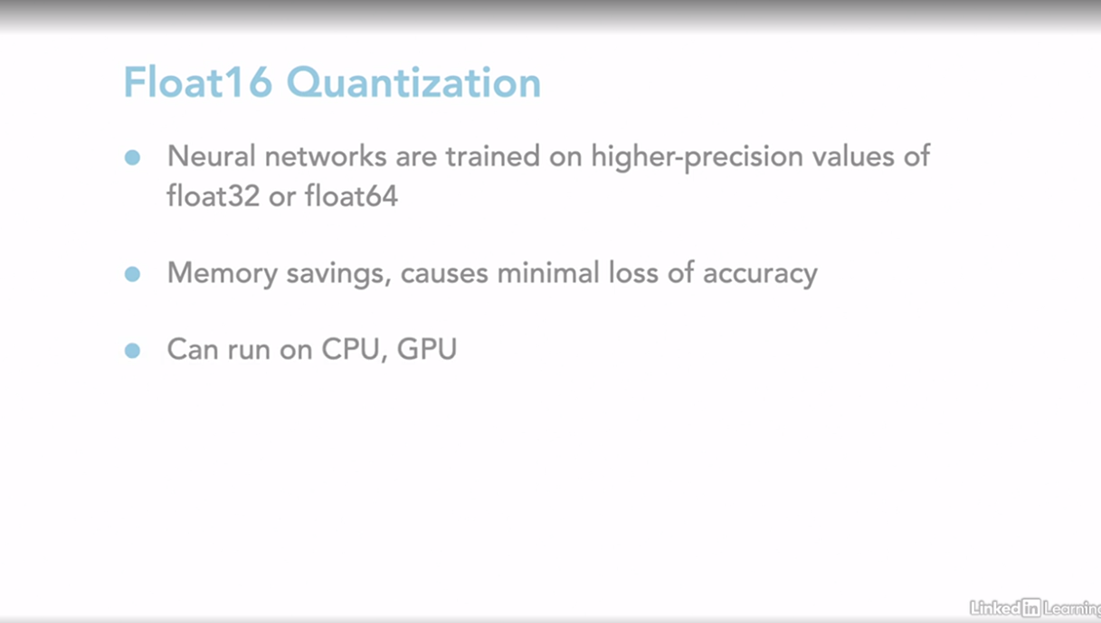

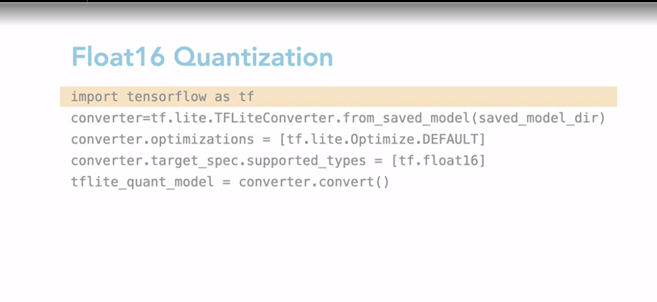

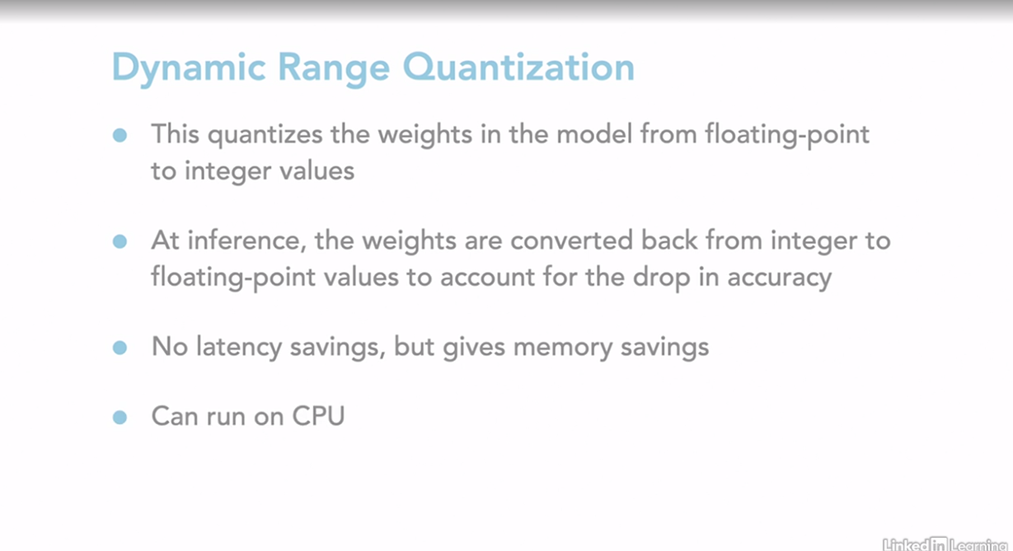

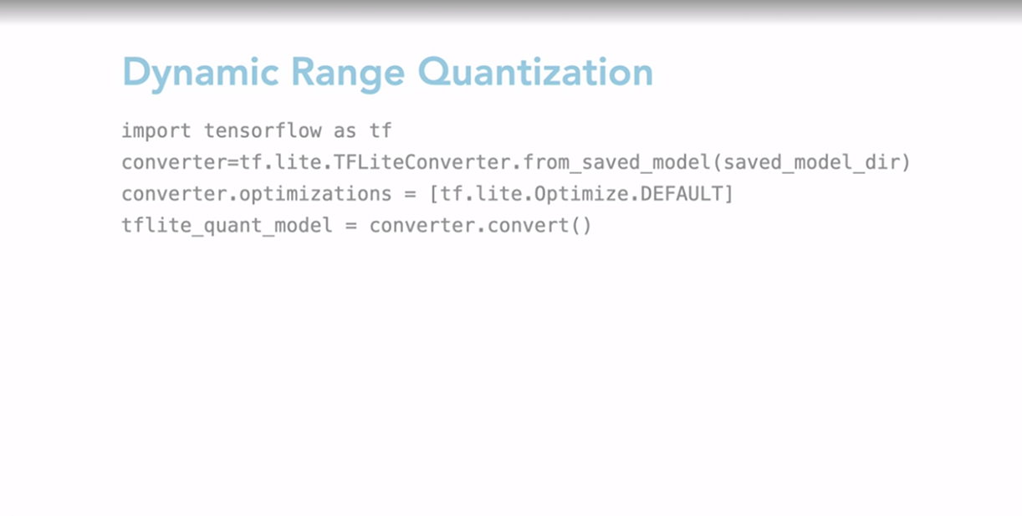

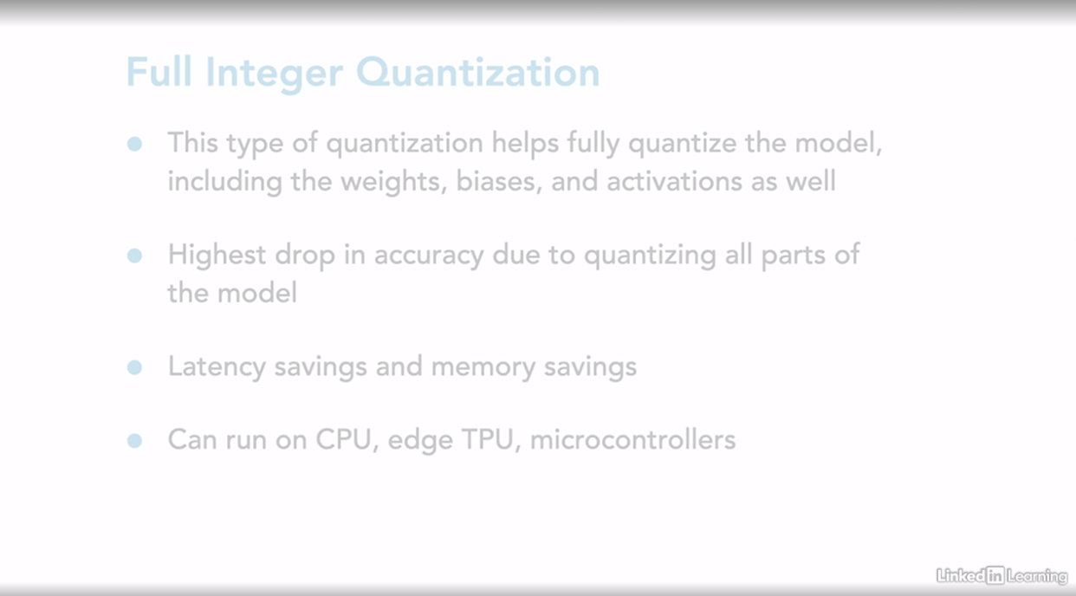

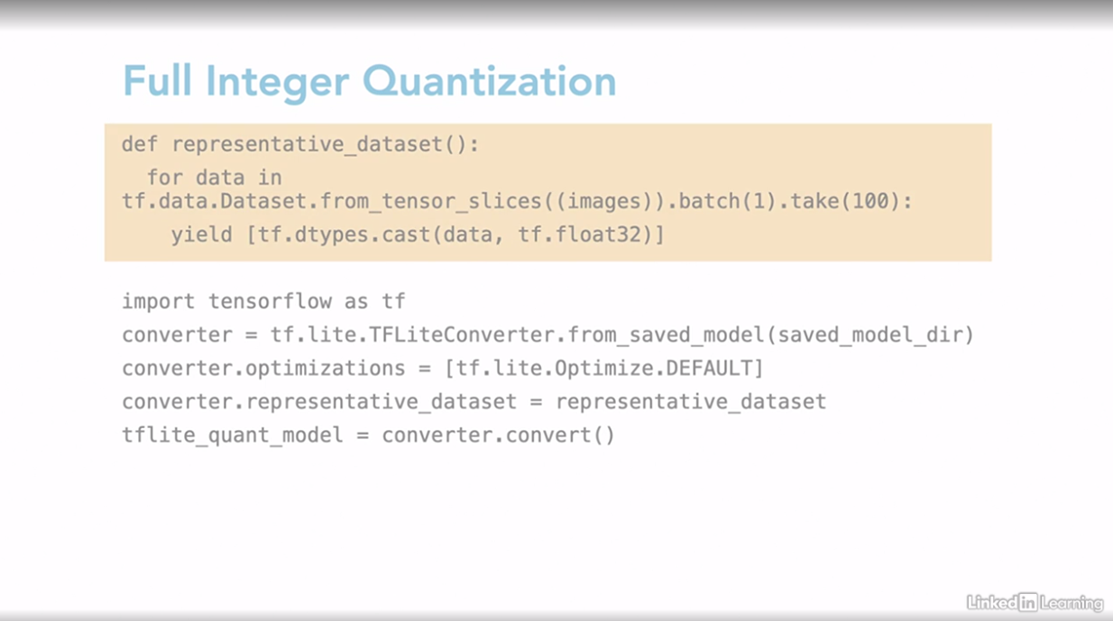

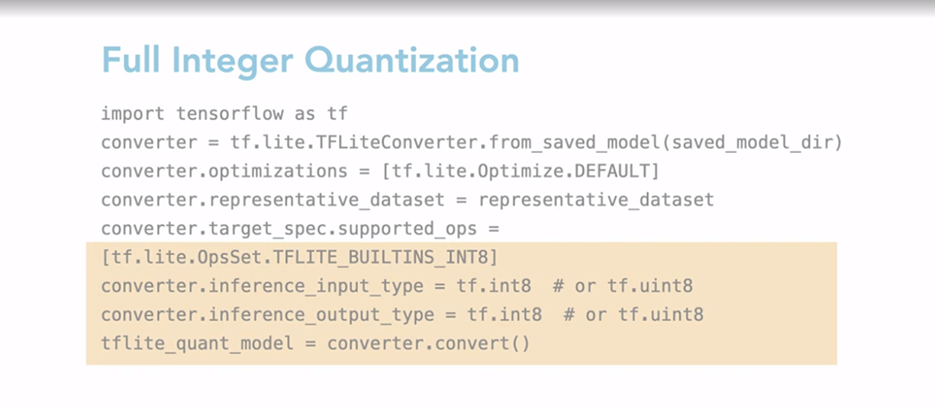

### **Quantization awareness training in TFLite**

After going through our previous lessons you must have realized that quantization offers great memory and latency savings. But often times that comes at the cost of a drop in accuracy of the model. To help solve this, TensorFlow Lite came up with Quantization-Aware Training. With QAT we are trying to see if the model can learn and account for the drop in precision during training, thus reducing the accuracy drop when we quantize the model for inference. To do this during training the model, we need to include the information loss that might be caused due to quantization. But how does that look for neural networks? The output or activation of each neuron in a neural network is computed by multiplying the weights with the inputs to the neuron, and then adding the bias. This is known as the forward pass of the network. Neural networks learn by comparing their output with the expected output, and then upgrade their way to reduce that error. This is known as the backward pass. In QAT we simulate the low precision behavior in the forward pass by actually quantizing the weights and the activations during the computation of each layer. The backward pass remains the same and uses floating point weights. So what is the advantage of Quantization-Aware Training? With QAT the model learns about the loss of precision and can account for it when quantized for deploying to edge devices. This helps to reduce any potential drop in accuracy. Furthermore, there were also some observations made by TF Lite while building this technique. mobilenet, which is a lightweight convolution neural network specifically designed for embedded and mobile devices, has two versions, V1 and V2. Version one was built to replace the existing expensive convolution neural network. Whereas version two offers more convolution layers and better support for connections in the network. Thereby making it slightly faster. Finally, a ResNet-50 is a convolutional neural network that is 50 layers deep. The authors observe that mobilenet offers higher accuracy in QAT than post-training quantization for all three networks where there is a significant drop in accuracy. So, let us jump right into the code and get our hands at Quantization-Aware Training. To use QAT with TensorFlow Model Optimization Toolkit, We need to first convert all the layers in our model to the Quantization-Aware version. We can do this by using quantized model function. After that we can compile and train our model like we normally do in TensorFlow. If you print the model summary you will see all the layer names that have been prefixed with quantization. After the model has been trained you can quantize it using TF Lite. You should see that there has been little to no accuracy drop in the quantized model as compared to the original model.

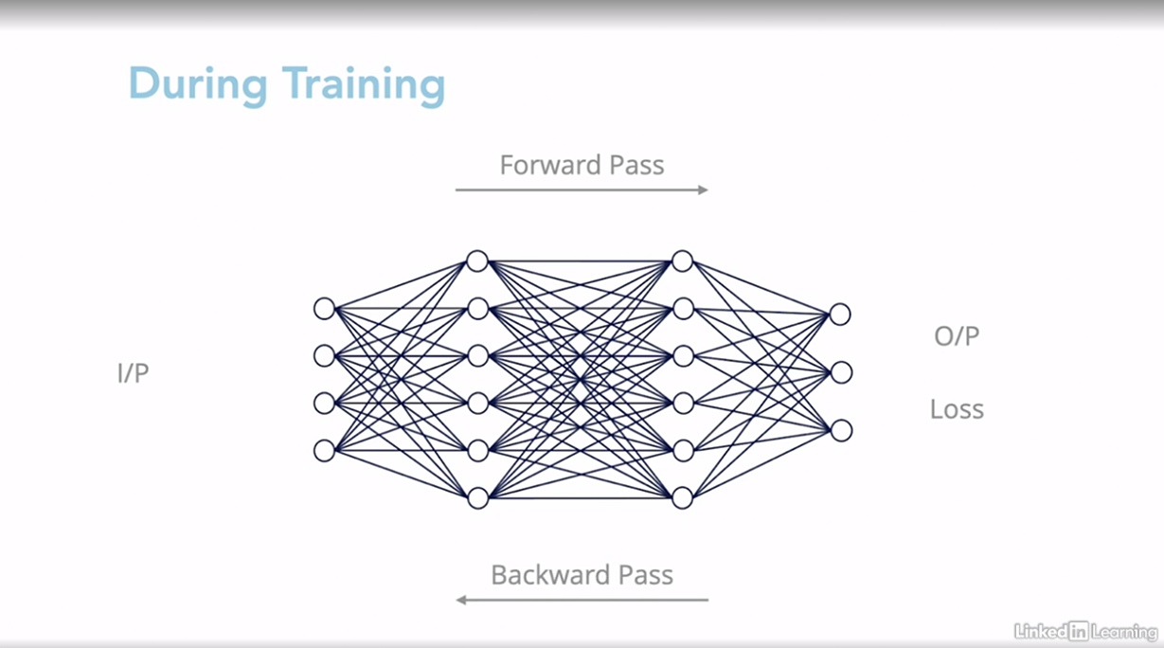

In this we do quatazation vehicle performing forward pass not in backward pass.

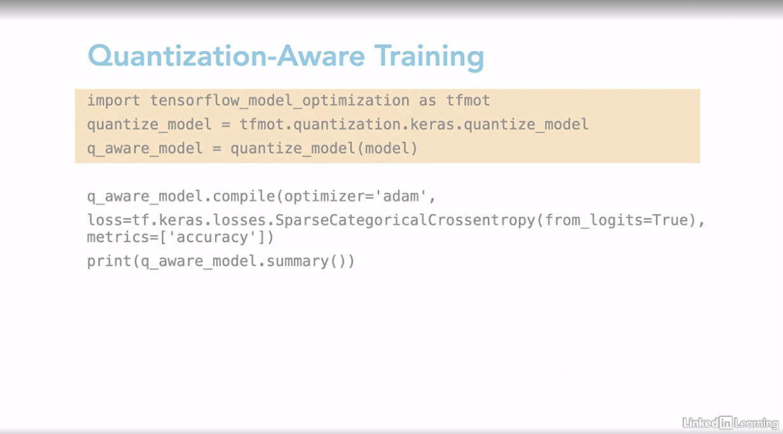

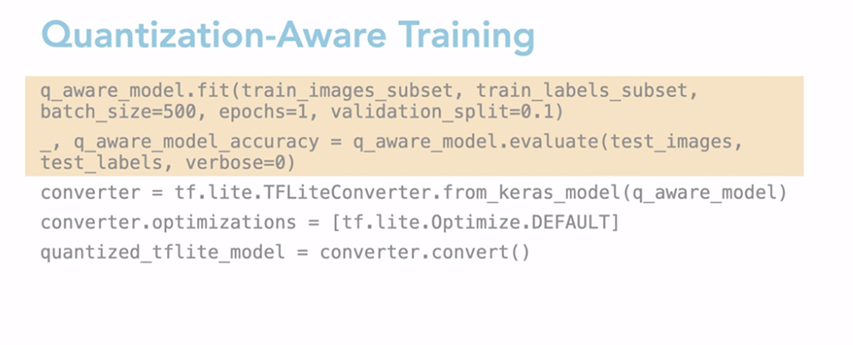

### **Pruning**

In this lesson, we have focused on optimizing neural network by primarily because as we move towards the edge, our compute power and memory resources become less. The first thing you spot when you look at a large neural network is the numerous neurons and connections present. But are large models really effective? Deep neural networks are traditionally trained to increase accuracy. To do this, researchers usually add a lot of parameters to the model in the hope that the model finds the best fit in the given search space. For example, these are the accuracy values for ResNet-50 versus ResNet-101. ResNet is a pre-trained convolution neural network with residual connections. ResNet-50 is 50 layers deep whereas ResNet-101 is 101 layers. The error does not reduce significantly when we move from ResNet-50 to ResNet-101 even though the number of layers is more than doubled. This means we have many parameters in the network which does not contribute to the final performance metrics. This is known as over-parameterization. With TinyML adopters quickly realized that such models are not built for systems that have to be deployed to the edge. Hence, the easy and straightforward solution was to cut down or reduce the size of neural networks and remove redundant parameters. We do this in a process called pruning. To prune a network, we will need to evaluate the importance of neurons and their weights and remove the least important neuron. This will lead to a slight drop in accuracy. To counter that, we fine-tune our pruned model and evaluate the results. We can stop the pruning or repeat the process to get further compute savings. So what can be pruned from a neural network? Most of the parameters in a neural network come from weights. Each neuron has a certain number of weights connected to them. The magnitude of weights tell us how important those weights are for that neuron. To remove weights, we can replace low magnitude weights with zero. If we replace all weights to a neuron with zero then we essentially remove that neuron from the network. This is known as unstructured pruning or weight-based pruning. Let us move on the code explanation. In this example, we will prune low magnitude weights in a Keras model using TensorFlow model optimization toolkit. The first step is to specify how we want to prune our model with a pruning schedule. We will specify a pruning schedule where we will start by pruning 50% of the weight and keep pruning till we reach 80% sparsity. We will do this over hundred training steps. Next, we need to create a new model with this pruning schedule. We can then compile a model in a normal way. After that, we need to fine-tune our model by calling the fit method. Keep in mind, though we are fitting the model we also need to include the updated pruning step callback which will help to update the pruning wrapper for every training step. Does this really work? They tested their model on ImageNet using Image InceptionV3 and MobilenetV1 based model. If we look into magnitude based weight pruning TensorFlow currently reports 6X improvement in model compression with minimal loss in accuracy. One can notice that even with 87.5% sparsity of networks which means 87.5% of the network was pruned, there was only a 2% drop in accuracy thus making these models perfect for low resource microcontrollers or compute devices.

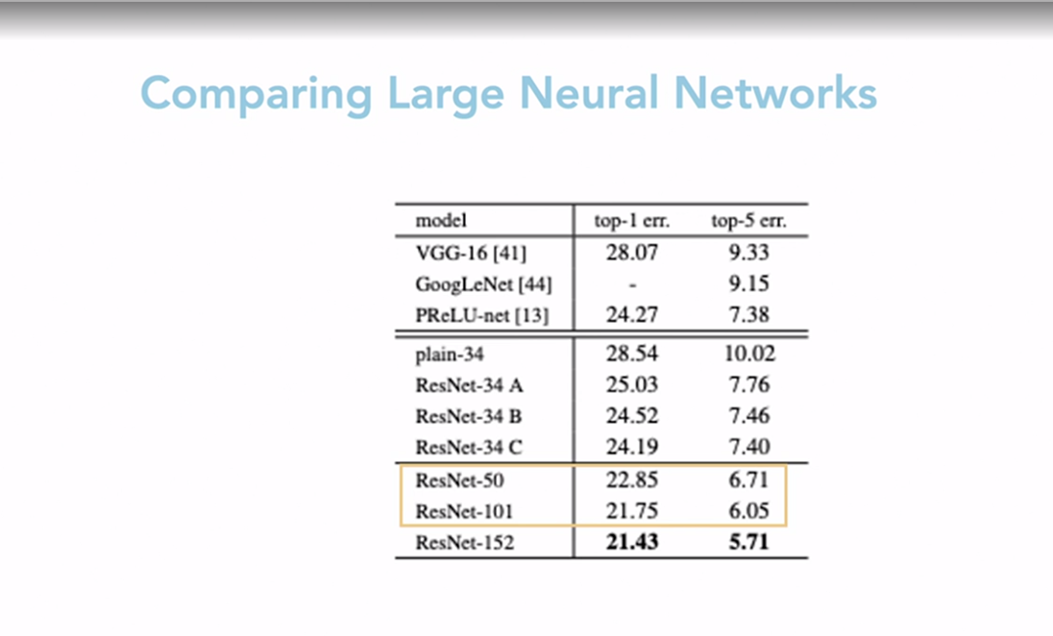

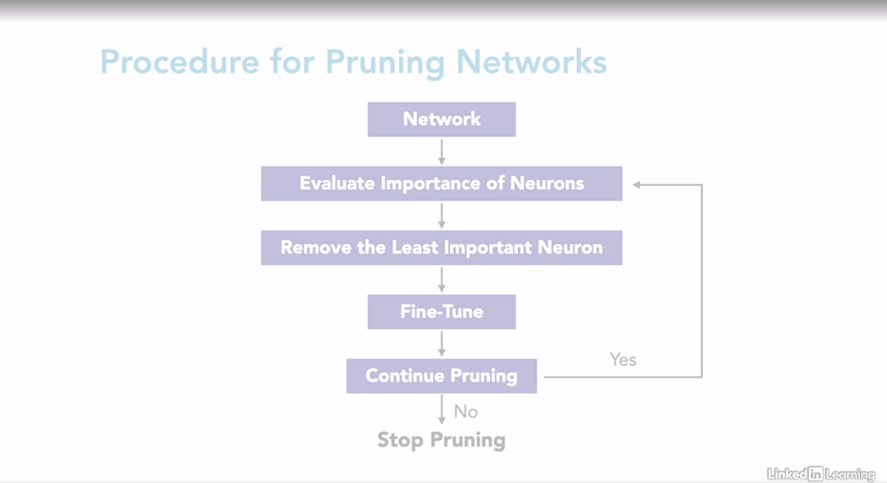

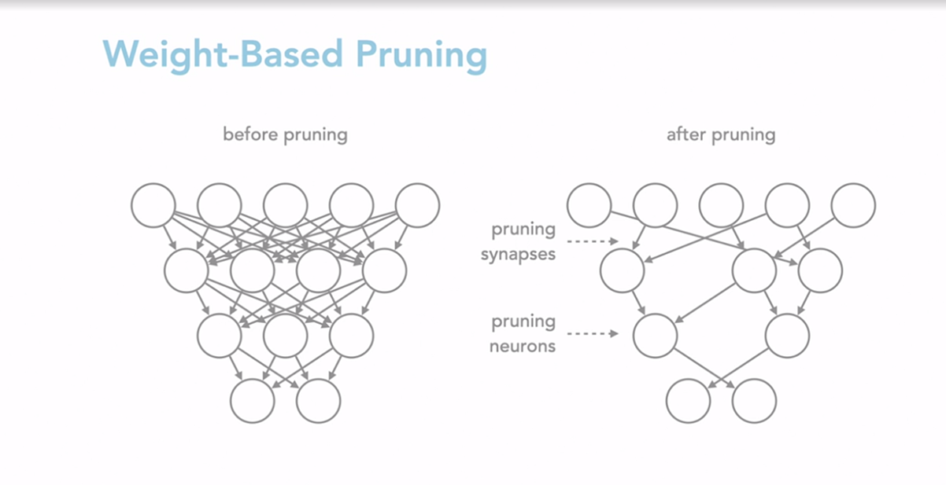

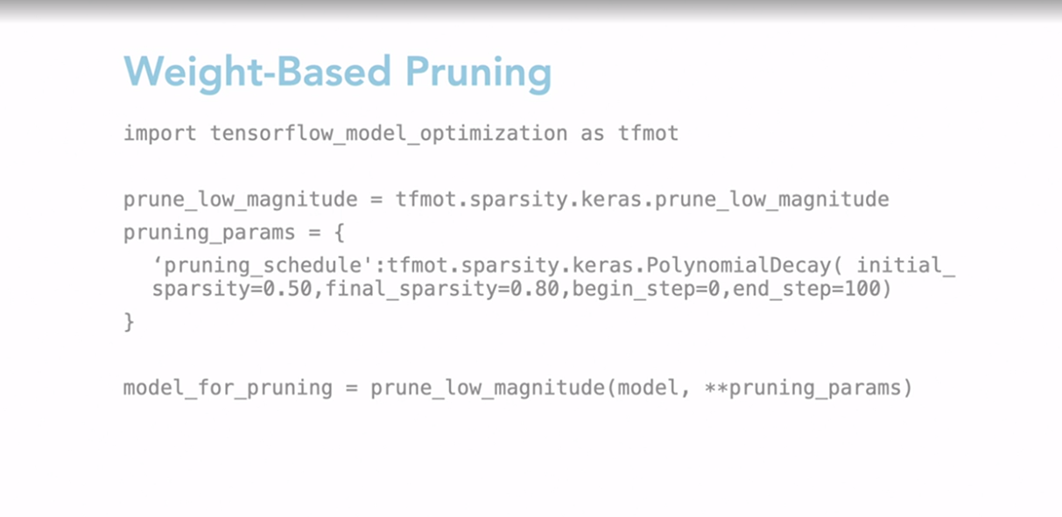

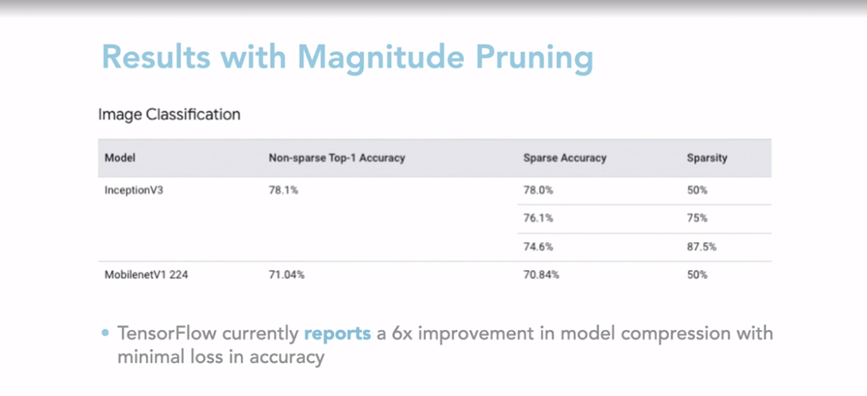

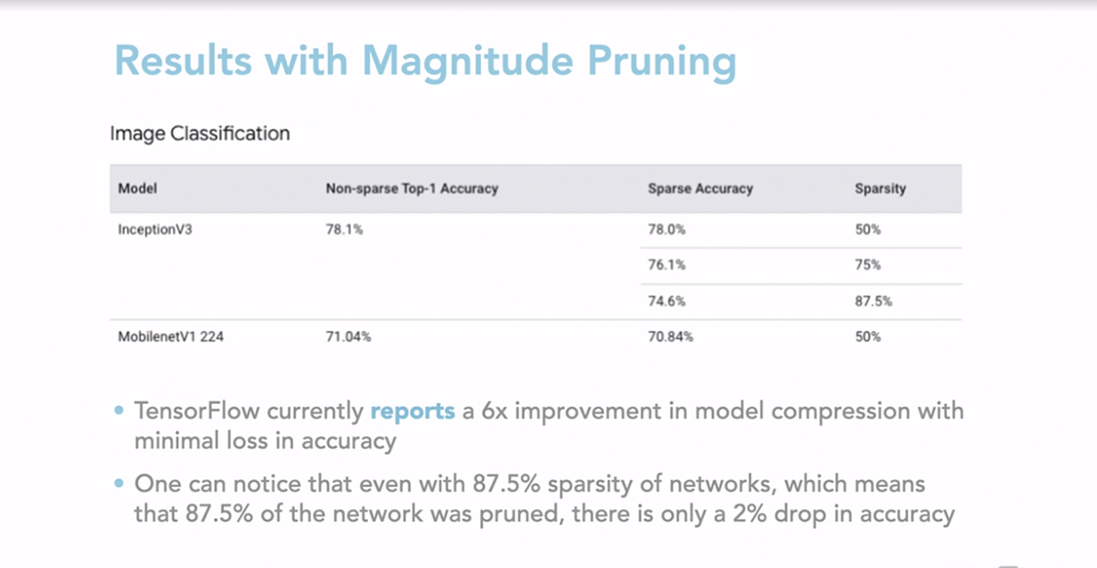

### **Knowledge distillation**

One of the popular methods to get high accuracy is to use an ensemble of models instead of a single model. To get a prediction we can average the predictions across all of these models. While for small and simple data sets we can use an ensemble of small models, as we shift towards larger data sets and more complicated problems, we need to use deeper neural networks. For deploying to the edge, it becomes computationally expensive to save and execute many small models, let alone an ensemble of large models. What if instead, we could distill the knowledge of many large models into a single model? Knowledge distillation is a process of compressing information from larger models or ensembles of models to a small and single model. So how do we do this? Remember that we want our teacher model to transfer its knowledge or internal representation to a student model. Let us go through the process of neural network for a simple classification problem. When a model makes a prediction, it assigns probabilities to each class. These probabilities are known as soft labels. When we perform knowledge distillation, we use these soft labels as labels for the student model. So when we train the student model on the same data, it is able to learn internal representation of the teacher and then produce the true labels needed for the result. Since the student model is trained using labels generated by the teacher, we can also use unlabeled data to train the model. Moreover, since the student model is smaller, it can be deployed to edge systems, thus making the system ideal for tiny ML or deep learning and microcontrollers. Let us look at the code explanation to implement this. The function shows how you can train a student model using the outputs from a teacher model for a one training step. The function takes two parameters to training data and its label. We first get the output from the teacher and the student networks. We compare these to get the distillation laws, and then apply the gradients. To see how well our student model is actually training, we can also calculate the student laws by comparing the student model output with the actual label. This is called a student loss. There are some interesting results to be taken away from using knowledge distillation. The original paper and knowledge distillation covers the experiment on speech recognition. The authors used an ensemble of deep neural networks that are used for automatic speech recognition. The metrics used to understand the results of frame accuracy and word error rate. The key takeaway is that a single distill model is able to get similar accuracy of that ensemble system with 10 models.

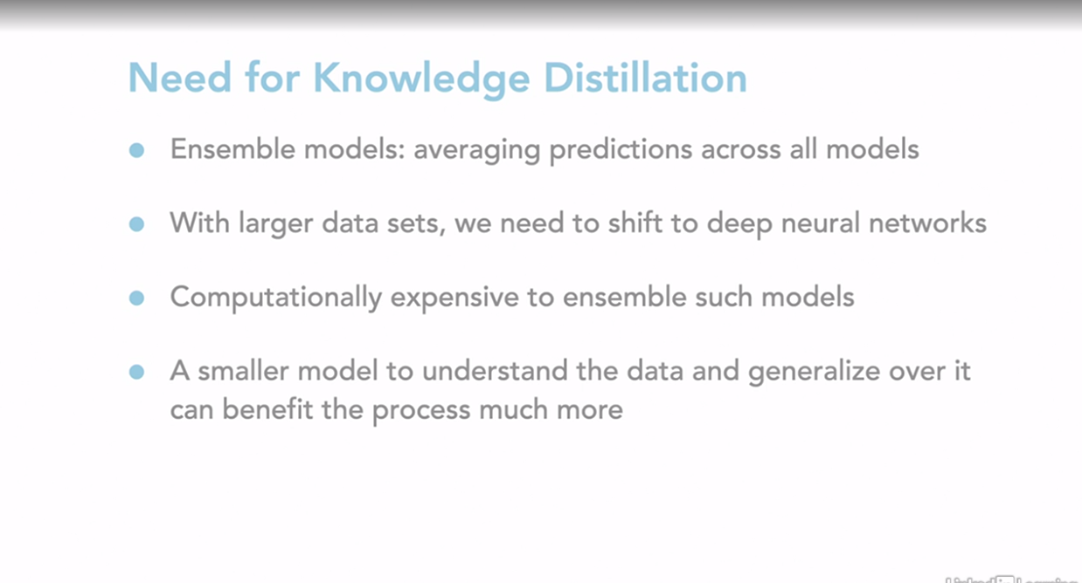

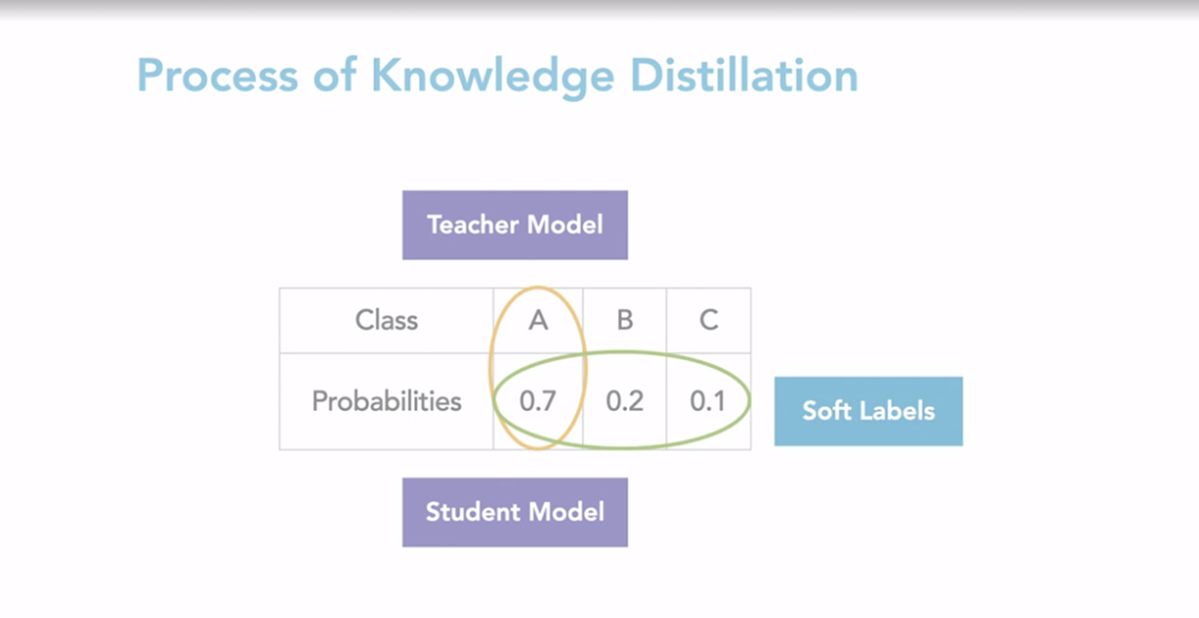

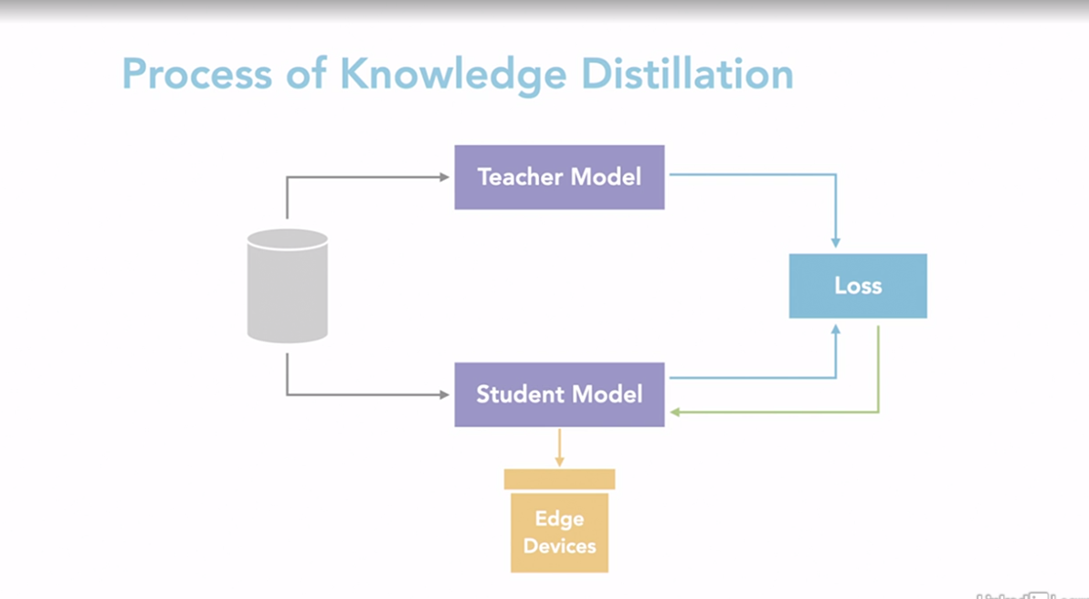

Student model is trained on input and output (softlabel) from teacher model and hence it has idea of the teacher model and we can also use the new dataset to train it

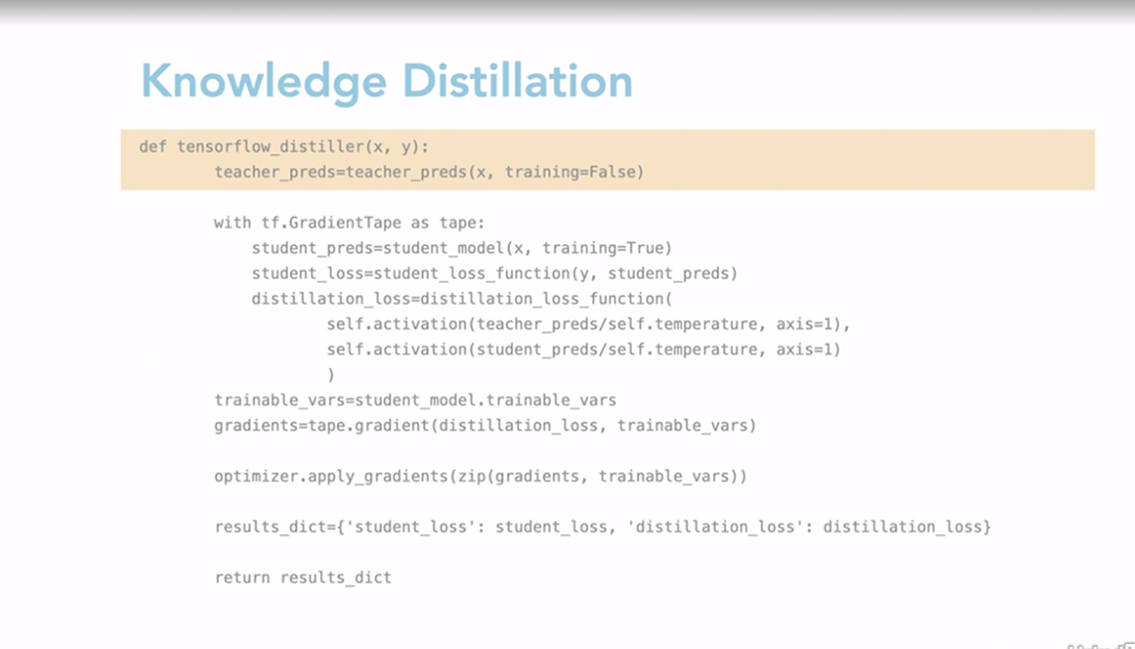

### **Compare results of optimization**

In this challenge , you will have to quantize a train model and check for changes in model metrics. You will have to quantize your model into both INT8 and Float16, and then compare the drop in accuracy and reduction in model size. There are cells to train a model on the MNIST dataset. There is also a function that you can use to calculate the accuracy of the model. You will have to finish the cells with to do. You can expand the cells in the solution notebook if you get stuck or to verify your answer. The first step is to import the packages we need. We will be using TensorFlow and keras to train our models. We will also be using numpy to evaluate the performance of our model. Later on, we will be using OS to find the size of our original and quantized model. Training a model on MNIST. TensorFlow provides an easy API to download the MNIST Dataset, separated into training and testing dataset. So first we will use that to load our data. Next, we will process our data by dividing all the pixel values by 255, to normalize them. After that, we will create a simple CNN model with two convolution layers and two dense layers. Finally, we can compile and train our model. Below is a function that can take a TFlite interpreter and run inference on the test set of the MNIST Data. We can use this to evaluate the performance of our original and quantized model. You can check out the evaluation of the model performance in these cells. Firstly, you pre-process and add batch dimension and convert it to Flow32, to match with the model's input data and in the post-processing you remove the batch dimension and find the digit with the highest probability. And finally you compare the prediction results with the ground label to calculate accuracy. Now comes the challenge, quantize the model weights into INT8, in the cell below write the code that takes a keras model that we trained before and then perform weight contestation to INT8. After that create a TFlite interpreter and use evaluate model function to check the accuracy of the model. You can refer to this cell above. Another to-do is quantizing the model weight to Float16 in this cell below write the code that takes the keras model we trained before and then performs weight quantization to Float16. Finally create a TFlite interpreter and use evaluate model function to check the accuracy of the model. In the last cell, save the model and calculate their size. In the cell below write the code to save put the original in the quantized model and then calculate the model size. You can use os.path.getsize function to get the size of a file. So let us get to it.

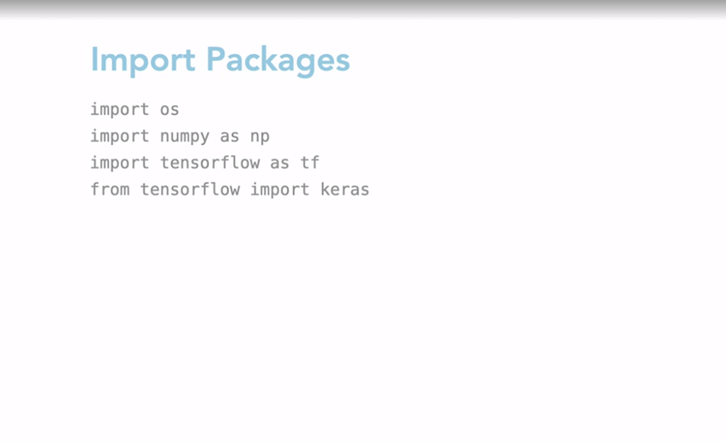

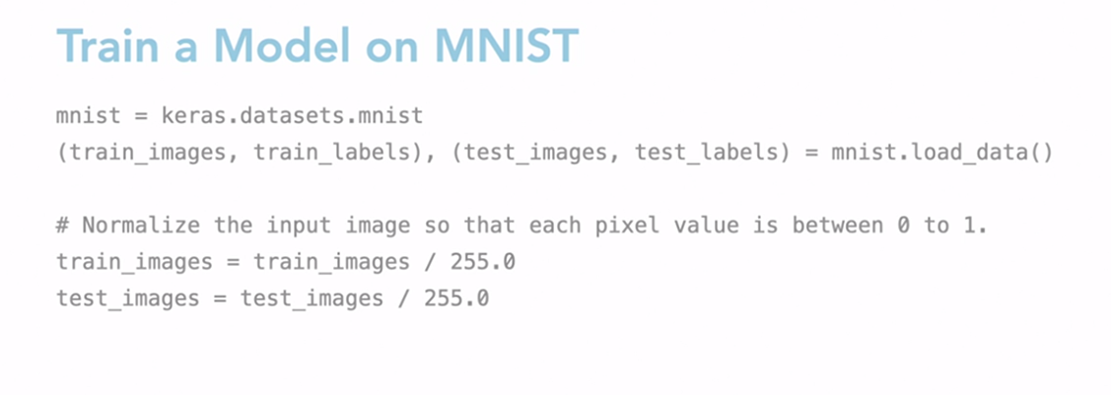

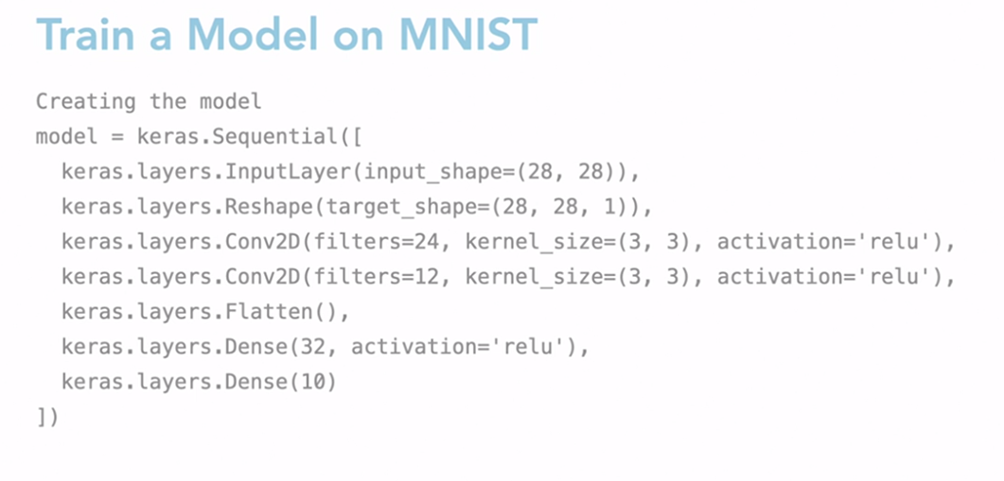

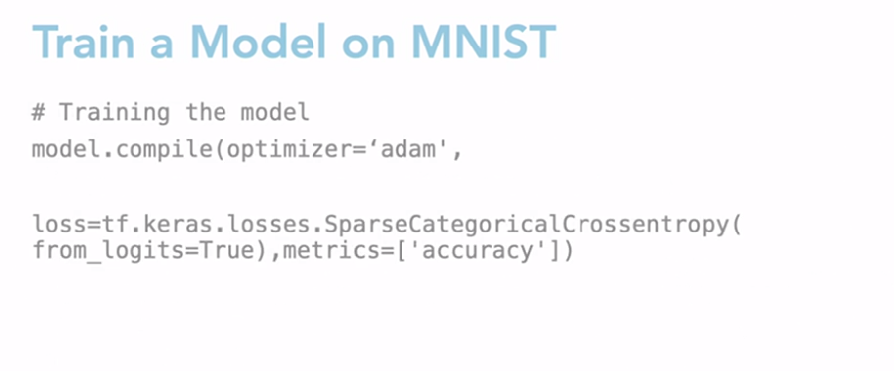

Solutions

Now, let us look at the solution from the challenge before. Firstly, you had to quantize the model to INT8. In the cell below, you had to write the code that takes the keras model we trained and then performs weight quantization to INT8, to create a tflite interpreter and also use evaluate_model() function to check the accuracy of the model. So to quantize the model weights to INT8, we first need to initialize a tflite converter object using the train keras model. Since by default tflite optimizes to INT8, we can use the default optimizer. Finally, we convert the model. Now, let us look at how to evaluate the model performance. After we have quantized the model, we need to evaluate its performance. To do that, we need to create a tflite interpreter object with our quantized model. You can then use the evaluate_model() function to get the model performance. The accuracy of the quantized model has dropped to 98.08% from the 98.68% accuracy of the original model. The next to-do was to quantize the model weight to FLOAT16. In the cell below, you had to write code that takes a keras model that we trained before and then perform weight quantization to FLOAT16. Finally, create a tflite interpreter and use the evaluate_model() function to check the accuracy of the model. Firstly, to quantize the model weights to FLOAT16, to compare the performance of a INT8 quantized model versus a FLOAT16, we'll have to quantize our original model to FLOAT16. Here, we need to specify the quantization level, which is FLOAT16, before we can call our convert function. Next, we need to evaluate the model performance, just like before we'll create an interpreter object with the model and the allocated tenors. We can then call the evaluate_model() function with the interpreter object to get the model's performance. The accuracy of the FLOAT16 model is 98.07%. Lastly, you had to save the model files and calculate their size. In the cell below, you had to write code to save both the original and the quantized model files and then calculate the model size. You could use the path, os.path.getsize() function to get the size of a file. One of the main advantages of quantizing the model is the deduction in model size. To check the size of a quantized model, we can save it as a file and check its size. To check the reduction in size, we will also convert the original model to tflite format before saving it. Note that this will not quantize the model, it will just shrink the model size by removing unnecessary data like training parameters. After saving the original model, the INT8 quantized model and the FLOAT16 model, we can see that the original model, which is FLOAT32 format, requires 0.85 MB, whereas intake requires one fourth the space and FLOAT16 model requires half the space.

**Deploying TinyML Model**

### **Edge impulse**

Edge Impulse is a popular tool that you can quickly train and deploy the models to TinyML devices. You can use their tool to collect and label data as well as create model training pipelines, benchmark your models performance, and test your model on a TinyML device. In this lesson, we will familiarize ourselves with Edge Impulse, and then we will use it to build our first TinyML project. This is what a typical Edge Impulse project dashboard looks like. In the middle, you will find helpful links to documentation and examples of how to use their tool. You will find documentation for collecting data using different hardware, including mobile phone, as well as how to design an impulse, which is an pipeline containing steps to pre-processed data, and then train a model, and then finally, make a prediction. On the right, you can also find quick stats about your project, like the number of device you are using, and the amount of data you've collected. The main part though, is on the left. Here, you can see different steps you need to do to build your project. The first step is to connect a device to your project. You should try to use similar devices for both training and testing your model. And this is where you can choose what devices you wish. Once you have connected a device, you can use it to collect data. Next, we need to design a pipeline that can take this raw data, pre-process it, and then train a model. We can do this in the impulse design step. Edge Impulse also has an eon unit, which can perform auto ML, and try to train an optimal model for a given hardware architecture. If you don't like your model's performance, you can update your impulse and then retrain it. You can verify your model's performance by testing it on some test data. You can also do life classification to see the real-time performance of your model on your final hardware device. Finally, once you are satisfied with your model results, you can deploy it on your target hardware.

### **Deploy a classification project to your phone (inbuilt features)**

Selecting transcript lines in this section will navigate to timestamp in the video

- [Instructor] Now that you know the different components of an Edge Impulse project, in this lesson, we will start to build our first project. We will be building a simple image classification model and use our smartphone as the deployment device. The project we will build is going to be a keyboard and mouse classifier. The model should take an image of a keyboard or a mouse as input, and then predict what it is. The first step is to connect our smartphone to this project to collect the data. You can do that by clicking on Devices on the left and then Connect on to new device. You can then scan the QR code to connect your phone. The QR code will open up a webpage where you can choose the type of data you wish to collect. Choose Collecting images, and then enter a label for the image you are going to take. For our project, the label can be mouse and keyboard. ML models train best when we capture a lot of images at different angles and lighting conditions. Try to capture at least 20 images for each label. Once you are done collecting images, you can head to the Data Acquisition center. Here you can see all the data you have collected. You can also edit incorrect labels and delete low-quality images. Now we are ready to create an impulse. You should see that an image data block has been created. Next, we need to add an image processing block. Edge Impulse makes it easy by recommending the blocks you can add. We can stick with the suggested image processing block. Next, we need to select a learning block. You can use Transfer Learning to fine tune a pre-trained model. After we save the impulse, you should see the blocks added onto the left. Let us go into the image block, check our settings, and then click Save parameters. In the transfer learning block, we can see the Edge Impulse has created a MobileNet model with some default training parameters. You can click Start training to train the model. Once the model has been trained, you should see the training results on the right. In case the training results are not good, you could collect more data and retrain the same model. In this case, the model trained really well. So we can go to the Live Classification tab to perform classification on the phone. You could also click the Switch to classification mode button on your phone and use that to take pictures and get results from the model you trained.

### **Challenge: Deploy a regression model to your phone**

Now that you know how to train and deploy a model using edge impulse, in this challenge, you will have to train and deploy your own model and work on your very first tiny ML project as part of this course. For this challenge you will have to build an audio classification model. Your first step should be to use your mobile phone to collect some audio data. For this project, you can record yourself speaking two words, hi and bye. Make sure that you can collect about 20 samples for each class so that the model trains better. After you have collected your data, you'll have to design an impulse. Remember to select a preprocessing block and a classification block. Feel free to experiment with different types of blocks to see which performs the best. Once you have trained a model, you should try to do a life classification using your mobile phone.

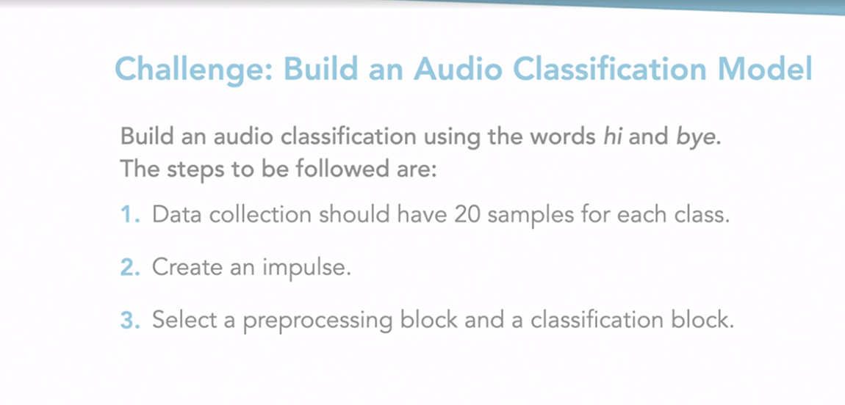

### **Solution: Deploy a regression model to your phone**

[Female Narrator] Let us jump onto the solution. In this video, we will see how you can train an audio classification model with edge impulse, and then deploy it to your mobile phone. The first step is to collect the data. Remember that we should use similar hardware for both training and testing. Since differences, in audio quality, may affect the train model. For this solution, you can collect data using your mobile phone. You can connect to your mobile phone by scanning the QR code. Before collecting your data, make sure you're using the right label. To make the model robust, you can collect data while speaking at different distances and angles from the microphone. Make sure you are also collecting, at least, 20 samples to help train your model better. Once you have collected the data, you can go to the data acquisition tab, on the right, to check your data, and remove any low quality samples and edit incorrect labels. The next step is to design an impulse. You should already see a block for loading the data. Go ahead and add a pre-processing block to the impulse. You can use the recommended MFCC block. For the learning block, we will use a classification model from Keras. Now, we can save our impulse and execute each block there. Once the model has been trained, you can check its accuracy, and retrain it, if it's too low. Finally, we can perform life classification using our mobile phone. We hope you had fun with this project.

**Tiny ML OPS**

### **Hardware devices**

Now that we have gone over the various optimization techniques, let us jump into the other crucial part of TinyML. TinyML sits between the field of embedded systems and machine learning. This means that TinyML practitioners require knowledge of not only machine learning techniques and models, but also the types of hardware devices available for deployment. So the hardware should not be an afterthought. In this lesson, we will learn about what kind of hardware devices to choose for deployment. It will be a high-level overview of the type of devices available, their pricing, and their characteristics. So let us start off with a basic question. What do you look for in a hardware device when building your first edge computing project? Firstly, make sure you go through the data sheet of the hardware device. A data sheet is a document providing the specifications for a particular product. It is usually published by the manufacturer and contains documentation about the device. It helps people make an informed decision about which hardware to choose. While you skim through a data sheet, make sure you check the following. Power requirements. Does my hardware device need a dedicated power source, or can it be battery powered? Environment. Let us say you want to deploy your project in a remote area, like a forest or a desert. Can my hardware survive the harsh conditions? You need to check the lifespan and the operating temperatures it can withstand. Cost. This is one of the critical aspects of your TinyML project. What is the budget of your project, and how much of that budget can you allocate to your hardware? Performance. Based on the cost, the performance of the hardware device can change. High performance hardware will also require more power, so you need to find the optimal performing hardware for your budget. Size. Based on where you want to deploy your project, the size of the device matters. So, for example, if your project has space constraints, you need to choose hardware with smaller dimensions. So make sure to check on this in the data sheet. Now that we have gone over how to choose the right hardware, let us go through some common hardware devices used for TinyML. Microprocessors. Microprocessors are general purpose hardware. They consume more power but are also more powerful. Raspberry Pi and Edge TPU Dev Board is a type of microprocessor. Microcontrollers. Microcontrollers, on the other hand, are used for simpler tasks. They are less powerful as compared to a microprocessor but also consume less power. Examples of microcontrollers are Arduino Uno and ESP32. Accelerators. Accelerators are gaining a lot of popularity in the TinyML domain space since they are built for specialized tasks. They often can be plugged into another hardware device and can take up complex computations required by neural networks. So they are small and more power efficient. Once such hardware is a vision processing unit by Intel called Neural Compute Stick. This is a plug-and-play USB stick which can be attached to a microcontroller, like the Raspberry Pi. It consumes less than two watts of power and has a dedicated neural compute engine. In addition to that, it has an accelerator that has depth estimation, optical flow, and motion estimation, which are important for vision-related tasks in machine learning. Cloud providers. In case of purchasing of different type of hardware is a roadblock in building your first TinyML project, you can choose some cloud providers which offer cloud services of edge devices, like Intel DevCloud. You can get access to Intel FPGAs, Neural Compute Sticks, CPUs, and GPUs over the cloud. This can help you prototype your first project before you buy your own. Do note, you might be limited by the hardware provided and cannot attach additional devices, like sensors, to test it over the cloud.

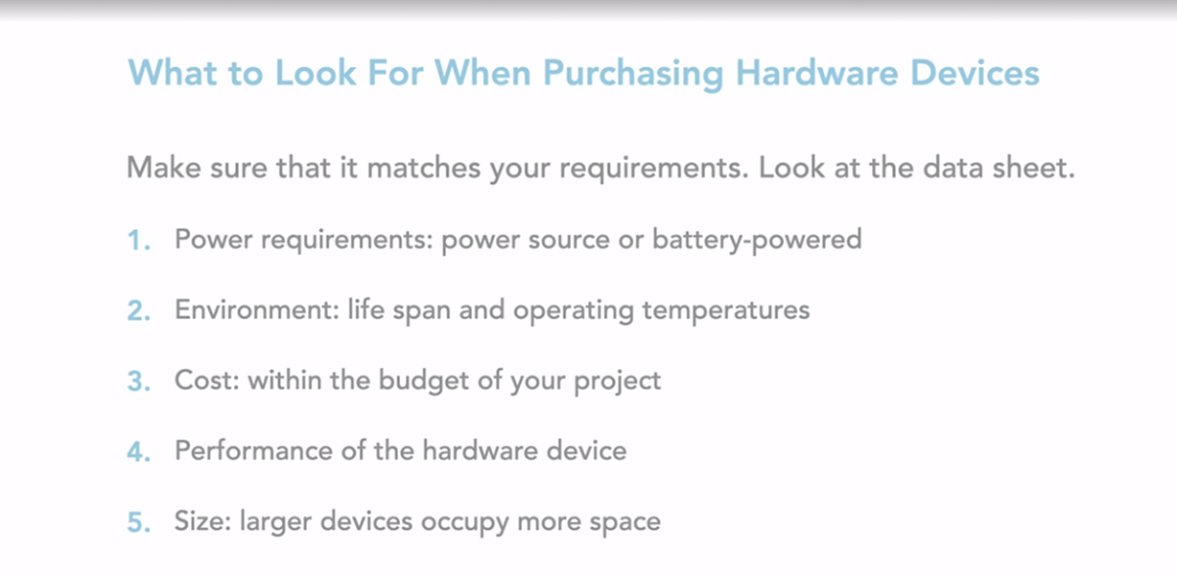

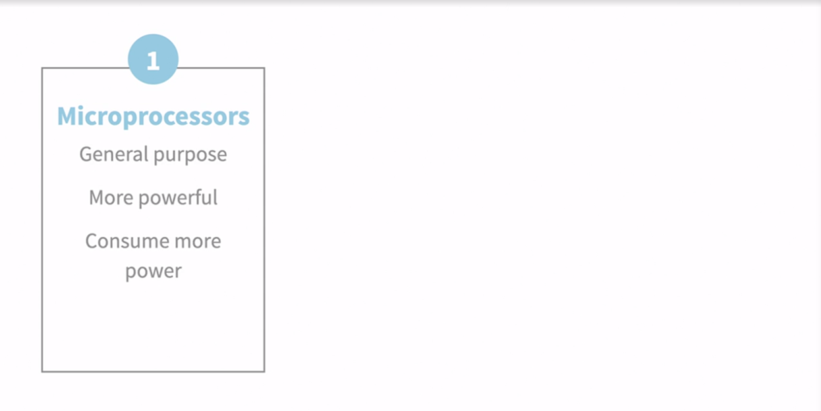

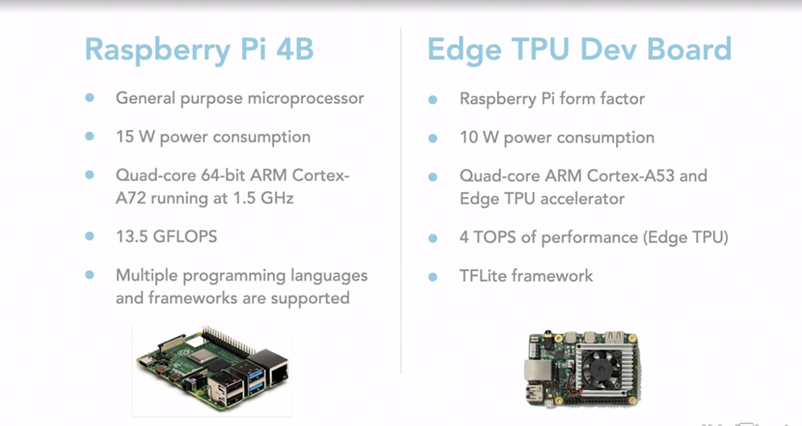

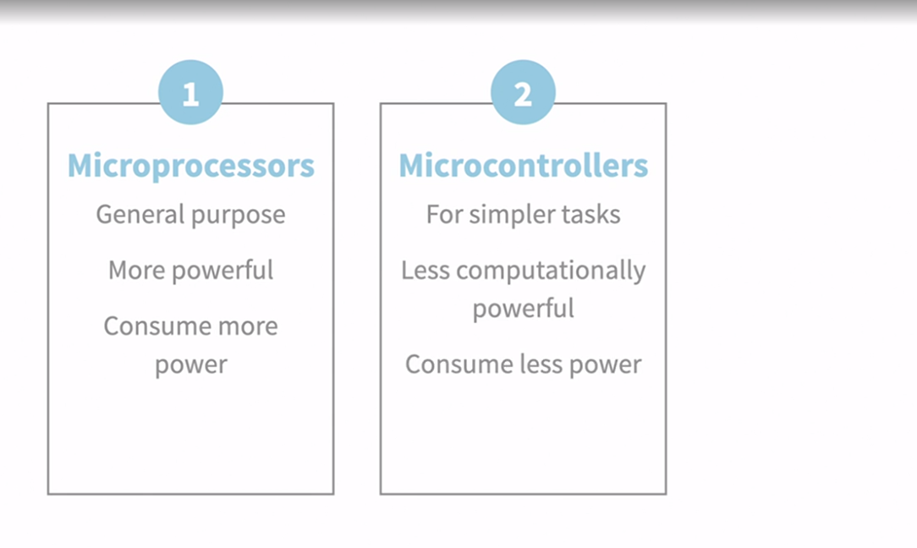

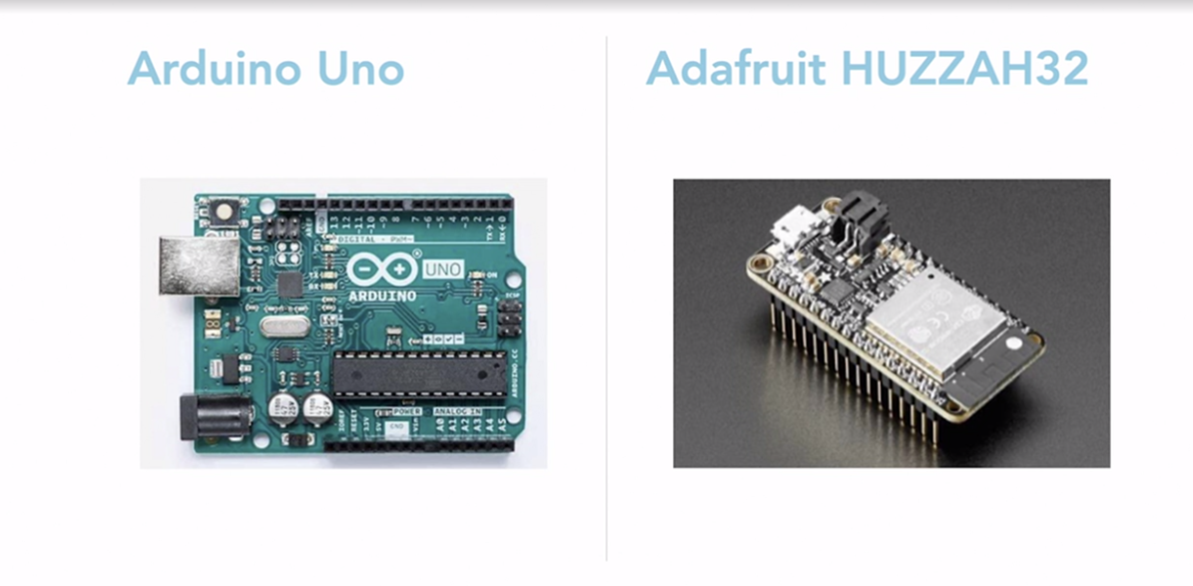

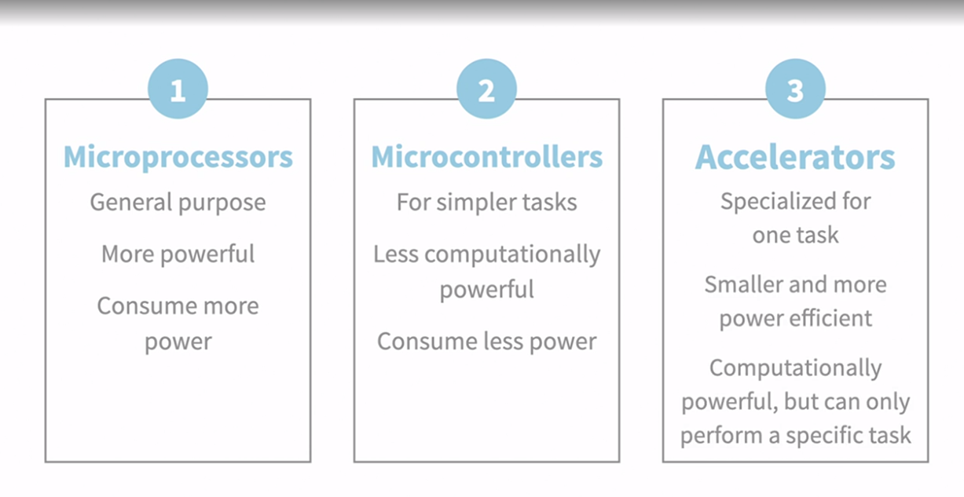

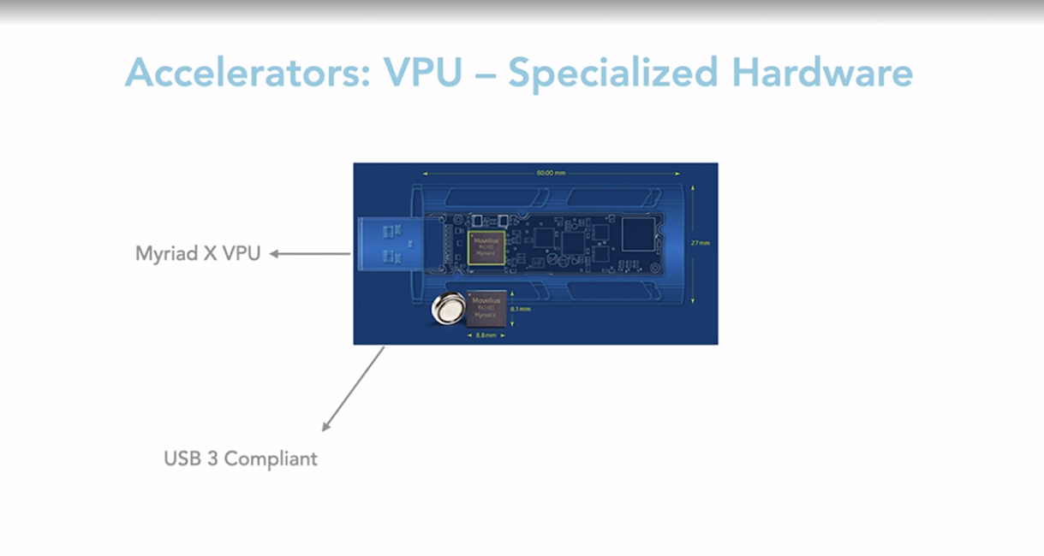

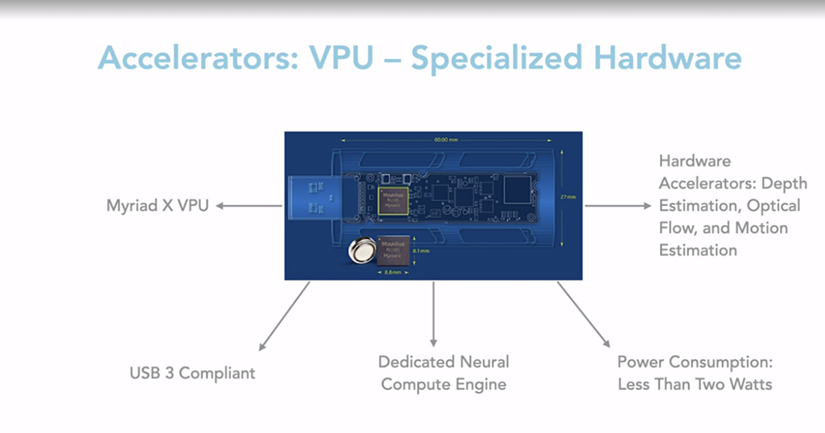

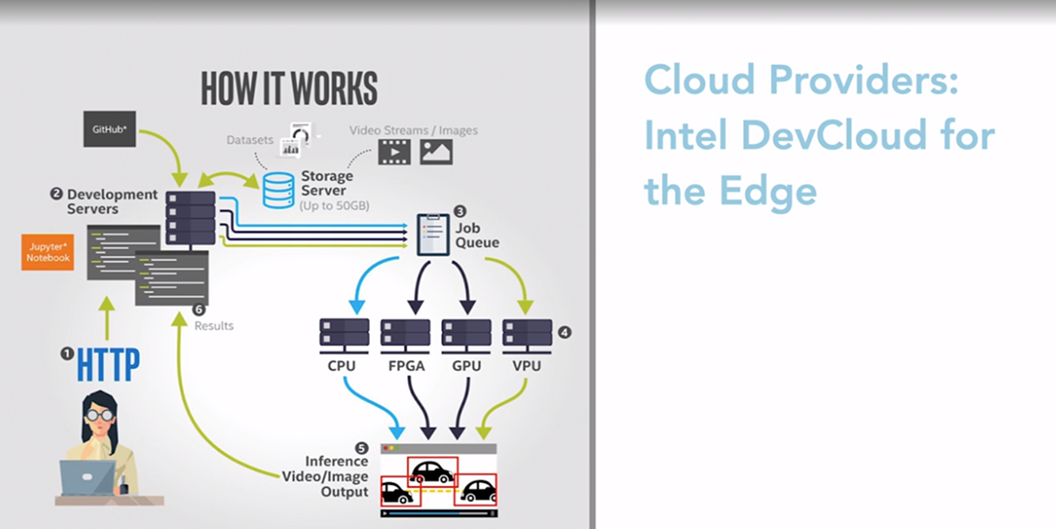

### **Bringing all the concepts together**

In this course so far, we have learnt about the software optimization techniques and the hardware used, and also tried our hand at a simple project. We have learned that TinyML exists in a complex ecosystem where it is important to leverage both hardware and software systems to deploy our first TinyML project. So let us think about TinyML systems as a whole. How to design these systems in an efficient manner and help scale these systems in the long term. There are several ways to start building your TinyML system. It is important you keep this in mind before starting your project. Let us look at the different parts of the TinyML pipeline, starting with model training. Optimization evaluation. You can evaluate your optimization by keeping the optimization techniques like quantization, pruning, or knowledge distillation while building and training your model. For example, if you determine that pruning is the most efficient way to optimize your network, then while training, you need to be aware of the filters and the layers of your network. This can help you in pruning the right layers and build a good model. Hardware evaluation. Don't forget to decide on your hardware while building your model. You need to determine your target device before building your model. For example, you cannot pick a TensorFlow-based framework to train your model for an Intel device. An Intel device supports its own OpenVINO framework. System evaluation. Once you have determined the hardware device, and the software techniques to be used, make sure you finalize the system requirements before building the solution. Changing the hardware and software is tough and will require several iterations to maintain compatibility. Benchmarking. Once we train our model and move into testing, it is important to determine what are the metrics to do the performance of a TinyML model. Unlike machine learning, which uses common metrics like accuracy or loss, we introduce more metrics to our TinyML systems. Latency. With model processing time, we also need to get the time to get predictions from the device. It is important that latency is as low as possible. Throughput. Along with latency, we need to calculate the number of predictions we get within a specified period of time. Latency is inversely proportional to the throughput. So we want the latency to be low whereas the throughput to be high. While deploying the model, we need to check to see how much memory does the model consume? Do remember the device has less memory, so we need to make sure not all of it is being utilized by the model. FLOPs. FLOP is a measure of computer performance that is calculated as floating-point operations per second. Since neural networks are composed of floating-point operations, you can calculate FLOPs in different layers like fully connected and convolutions in a model. Ideally, the FLOPs need to be as low as possible to be able to run smaller networks. You can achieve this by using optimization techniques like quantization. Now that we have looked into the best practices while training and deployment, our final pipeline consists of training a model, optimization. These both happen on the host device. And as we move on to deployment on the device, we have to monitor, benchmark and update. This follows in a loop and is the TinyMLOps pipeline.

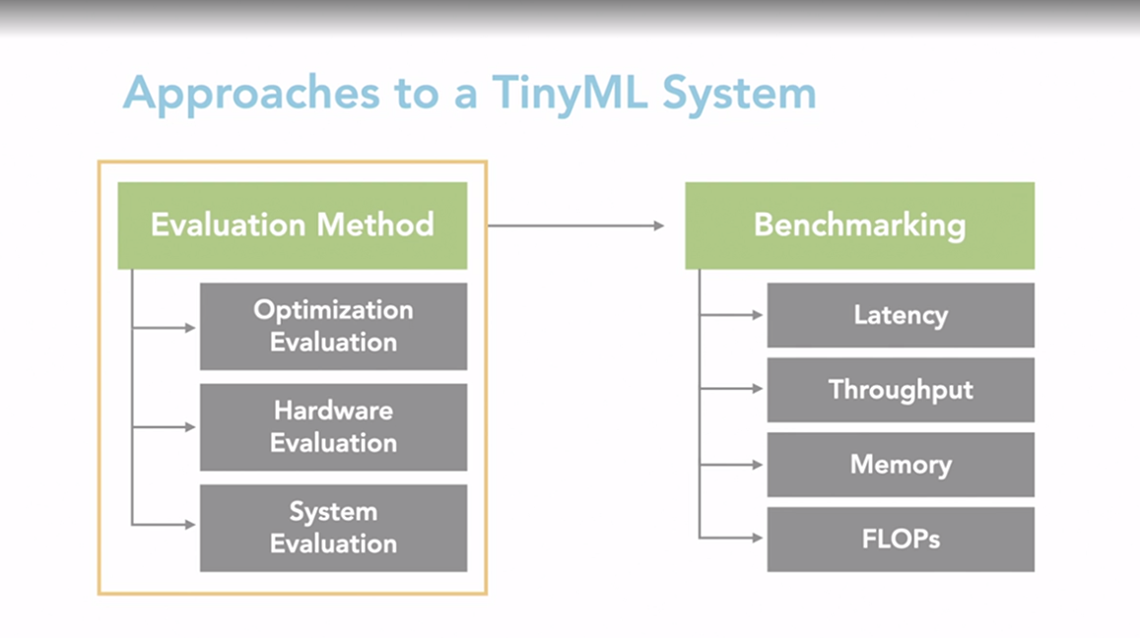

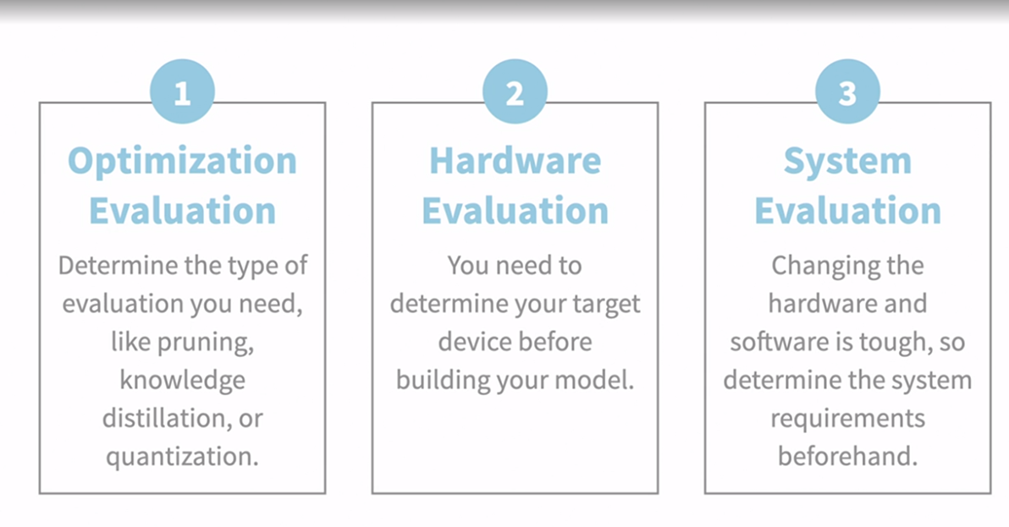

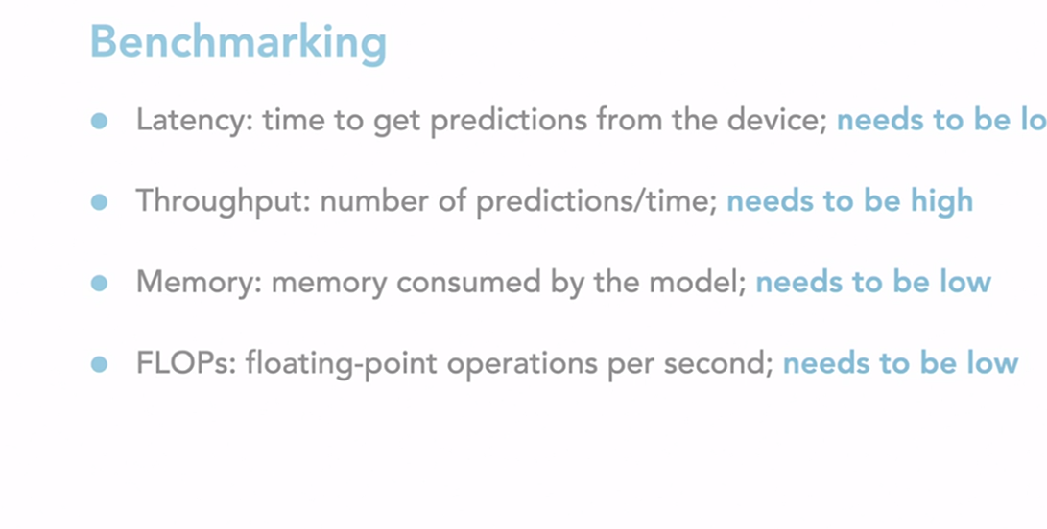

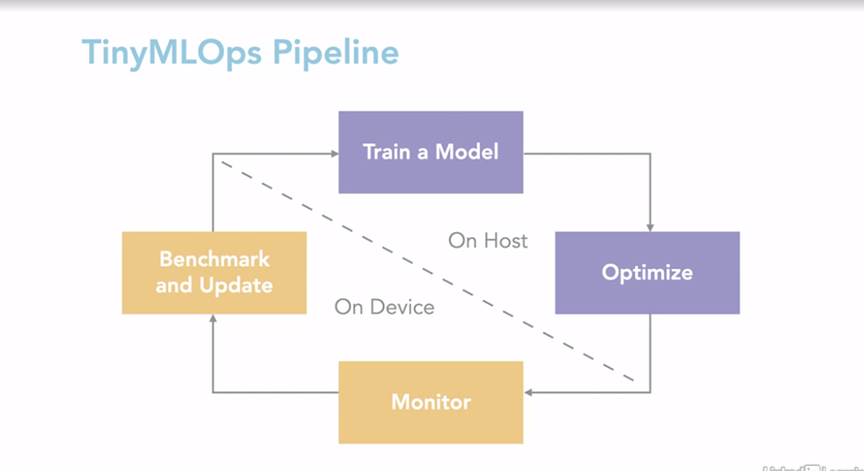

### **Resources for TinyML**

Thank you for going through the course material. We are nearing the end and want to make sure you walk away with the best resources possible. So in this lesson, we'll be focusing on resources to help you learn more about TinyML and some upcoming research directions to look for. There are some communities that offer free hardware and a chance to show your work like Hackster. If you want to check out cloud service providers, Intel DevCloud provides access via cloud for hardware. If you're looking to buy hardware from legitimate online stores, you can go Arduino store, Element14, Sparkfun or any other local providers you trust. For frameworks check out TensorFlow Lite, which currently supports quantization, pruning, weight clustering and support for Edge TPU. If you're using Intel devices, you can check out OpenVINO which also provides quantization, pruning, intermediate representations, and support for NCS. Finally, some other frameworks to look out for are ONNX, PyTorch mobile and DeepStream which is used by Nvidia devices. To deploy the first project, you can use a lot of open source tools and services. Edge Impulse is an application you used in the course for a jump start into your first project. To explore further you can try building TensorFlow Lite example apps which need some initial requirements like Android Studio for Android devices and Xcode for iOS on mobile phones. To learn about operationalizing TinyML systems at scale check out packages like ScaleDown. ScaleDown is an open-source neural network optimization frameworks for TinyML devices. ScaleDown has APIs for model conversions from your framework to whichever framework supports the algorithm you want to optimize your model with. Finally it can be difficult to properly optimize your models for Edge devices so ScaleDown also provides API for automated model optimizations based on your hardware restrictions. Check out their work on the link here. Lastly, you can also check out some other resources like courses on TinyML, like those on edX by Harvard university and a wonderful course on Computer Vision with Embedded Machine Learning by Shawn at Edge Impulse. Books are also a great source for continuous development. You can check out one of the popular books in TinyML by Pete Warden and Daniel, which works through TensorFlow Lite application for Arduino Nano 33 BLE Sense.

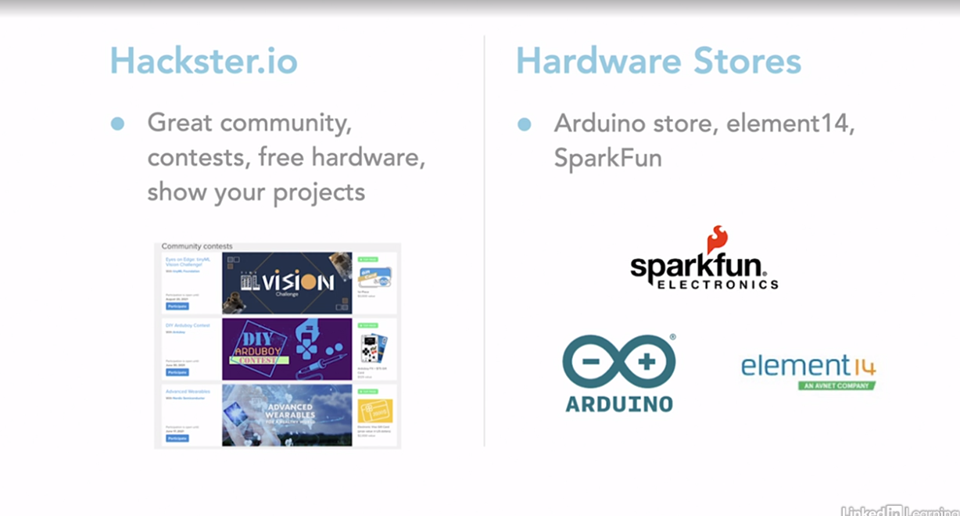

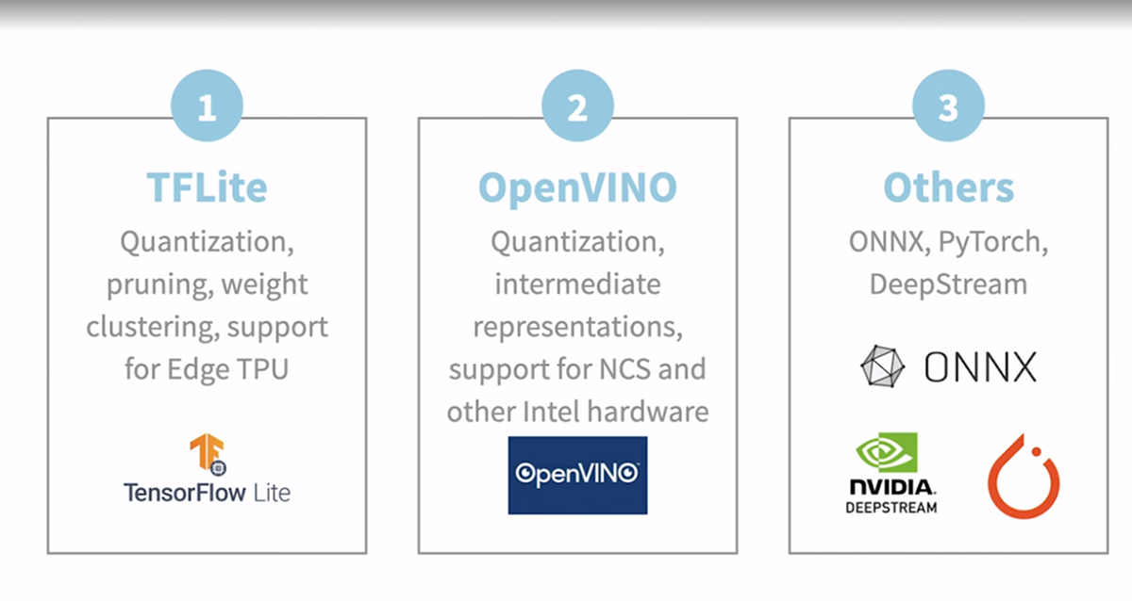

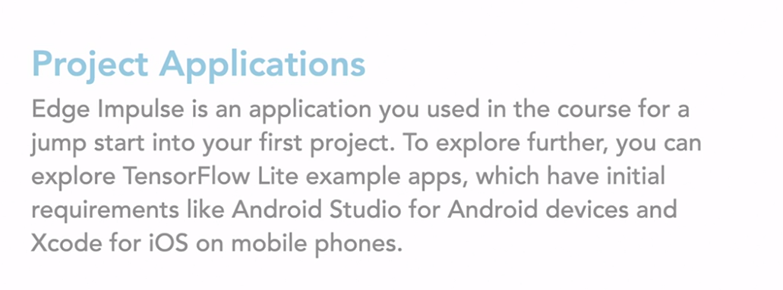

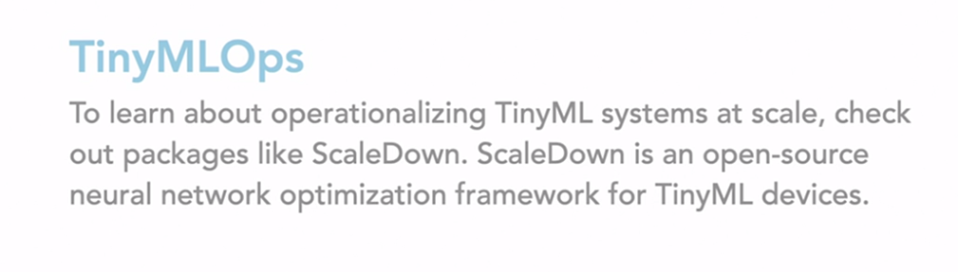

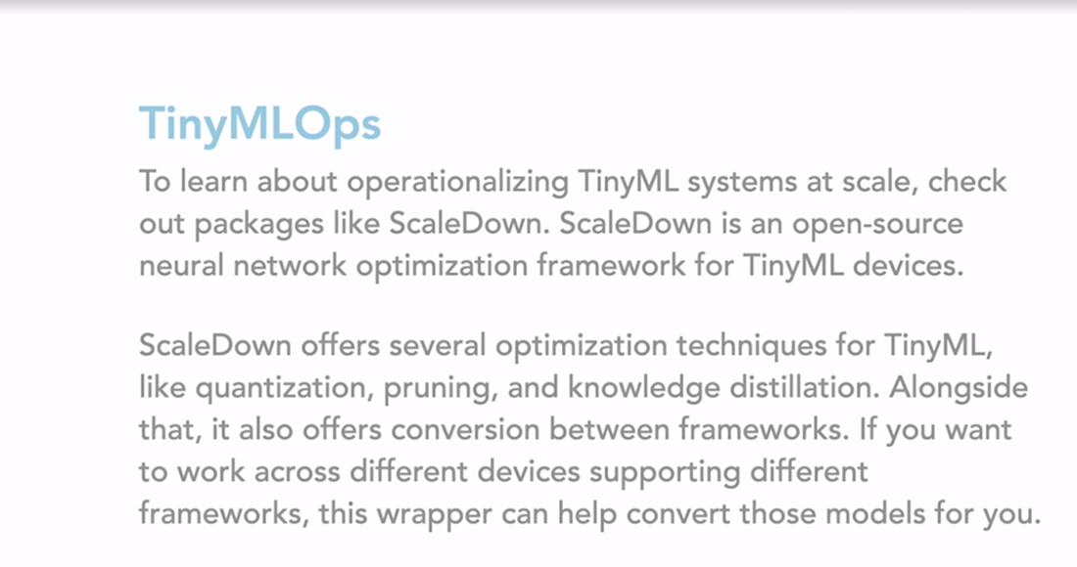

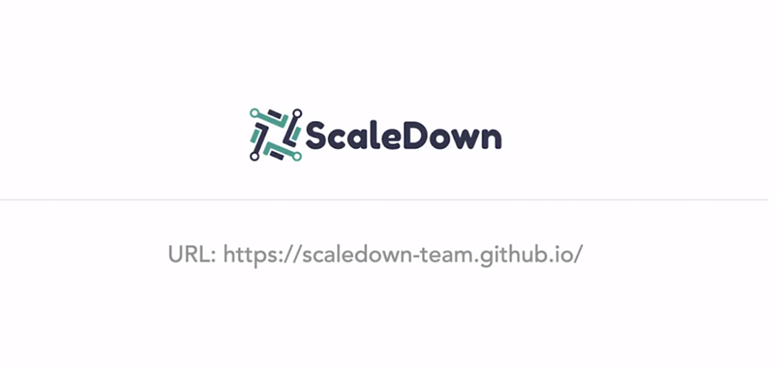



### **Future of the TinyML: Research directions**

The last chapter you learned about some of the tools and frameworks you can use to build TinyML projects. However, TinyML is a very active field with new algorithms and techniques being invented frequently. In this chapter, we will cover some resources that you can use to keep yourself updated with the latest developments in the field. A lot of TinyML research focuses on creating better optimization algorithms. These include trying to improve our current algorithms like quantization and pruning so that we can further reduce the model size and complexity without significant drops in accuracy. Over the last few years many new algorithms have also been gaining popularity like knowledge distillation, which we have learned about previously and early exits. Early exit is an interesting algorithm where we execute only a part of the model to get prediction, instead of the whole model. This helps to reduce the number of operations needed to execute the model and improves latency. Another interesting area of research is robustness and security of TinyML models. When we deploy a model we should make sure that it is not bias and that it is robust to changing inputs. Sara Hooker is a researcher who has done a lot of work in this field and has shown how compressing models especially for pruning can increase the model's bias. He has done a lot of work on the field of explainable AI. Since many TinyML systems are deployed in places where they can be easily accessed by attackers, there is a need to make our models robust to physical attacks. Shivam Bhasin from NTU is a researcher who has done a lot of work in this field and has even shown how you can access the model files stored on raspberry pi with less than $20 worth of materials. On the embedded side, a lot of research is being done on building low power devices to run on neural networks. Some of these advances include using neuromorphic hardware and building custom hardware to run binary and prune neural networks. Along with the following researchers working in these areas, another way to keep up with latest research is to follow research labs and organizations. For instance, MIT HAN lab does a lot of work on creating better optimization algorithms and the MIT energy efficient multimedia systems group works on energy efficient ML systems. Finally, if you want to learn more about the work being done follow TensorFlow blog, Pete Warden blog, or One More Epoch.

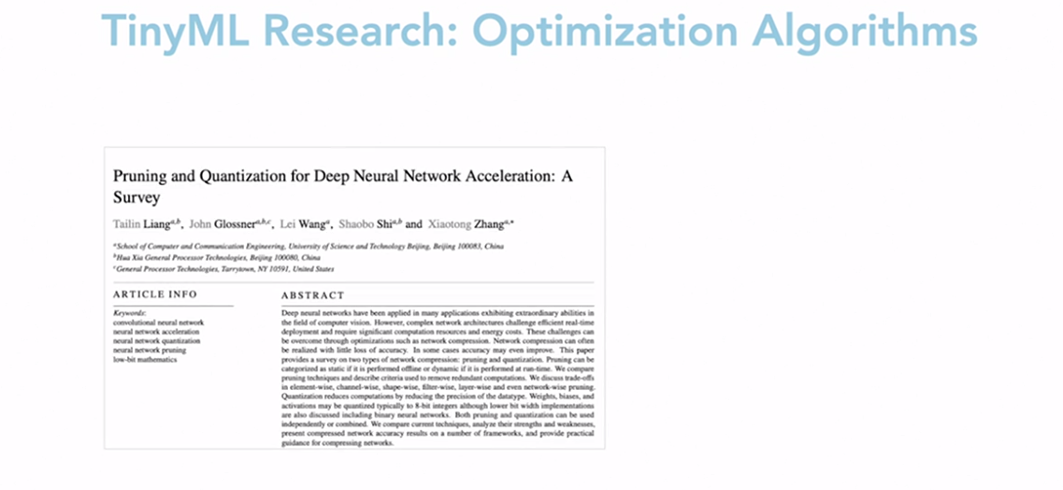

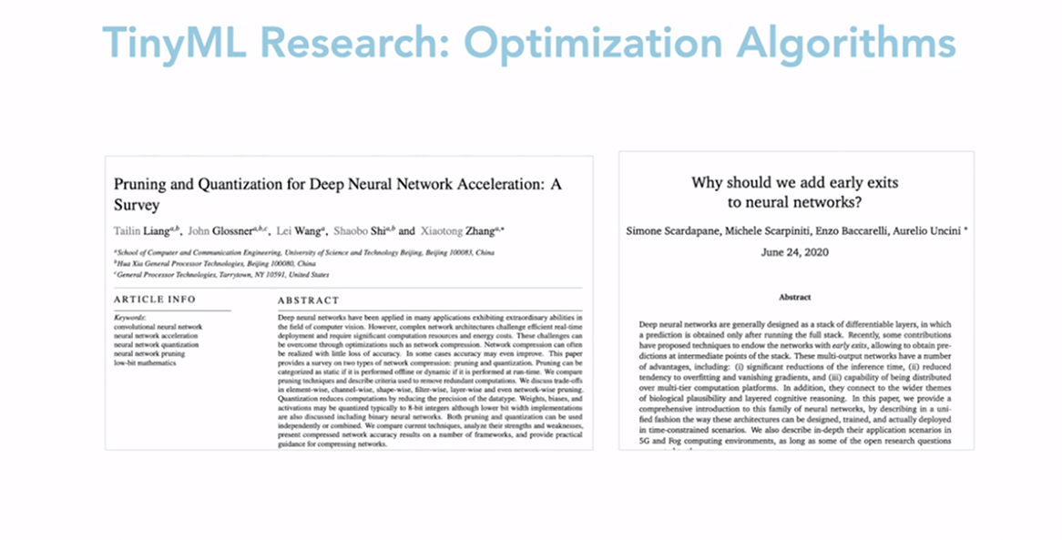

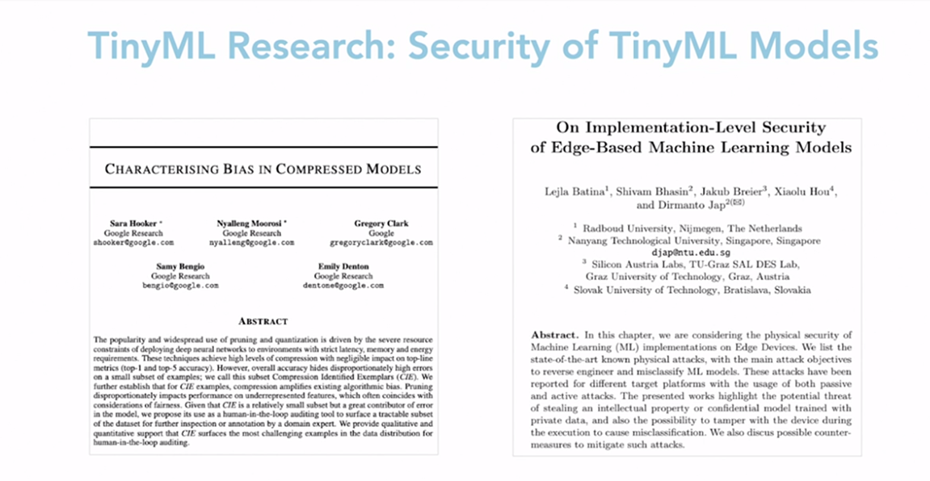

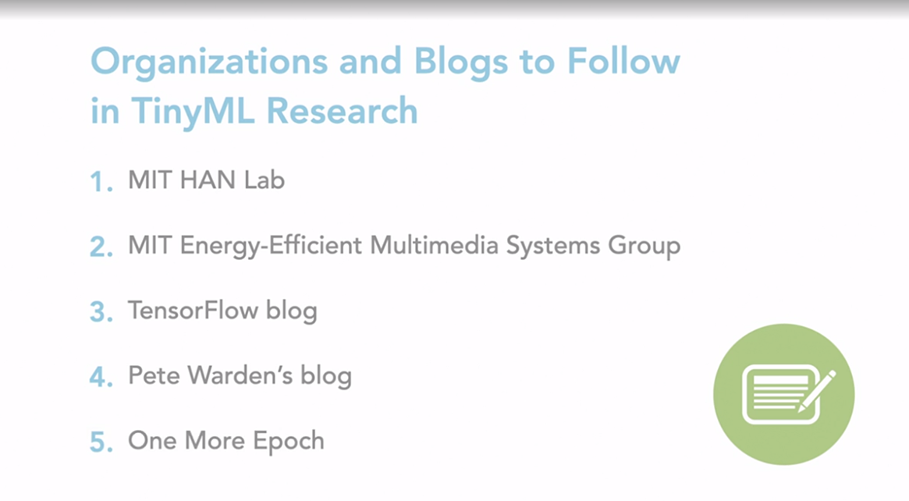

### **Next steps with TinyML**

Thanks for watching this course on Introduction to tinyML. I hope you learned something new and have a chance to appreciate tinyML all around you. Don't hesitate to reach out to me for feedback, suggestions, or any further collaboration. You can reach out to me on LinkedIn, Twitter, also feel free to check out my work and subscribe to my newsletter as I dive into exciting directions in tinyML. Don't forget to keep learning, and check out some LinkedIn Learning courses on deep learning and embedded systems.

